Python Framework

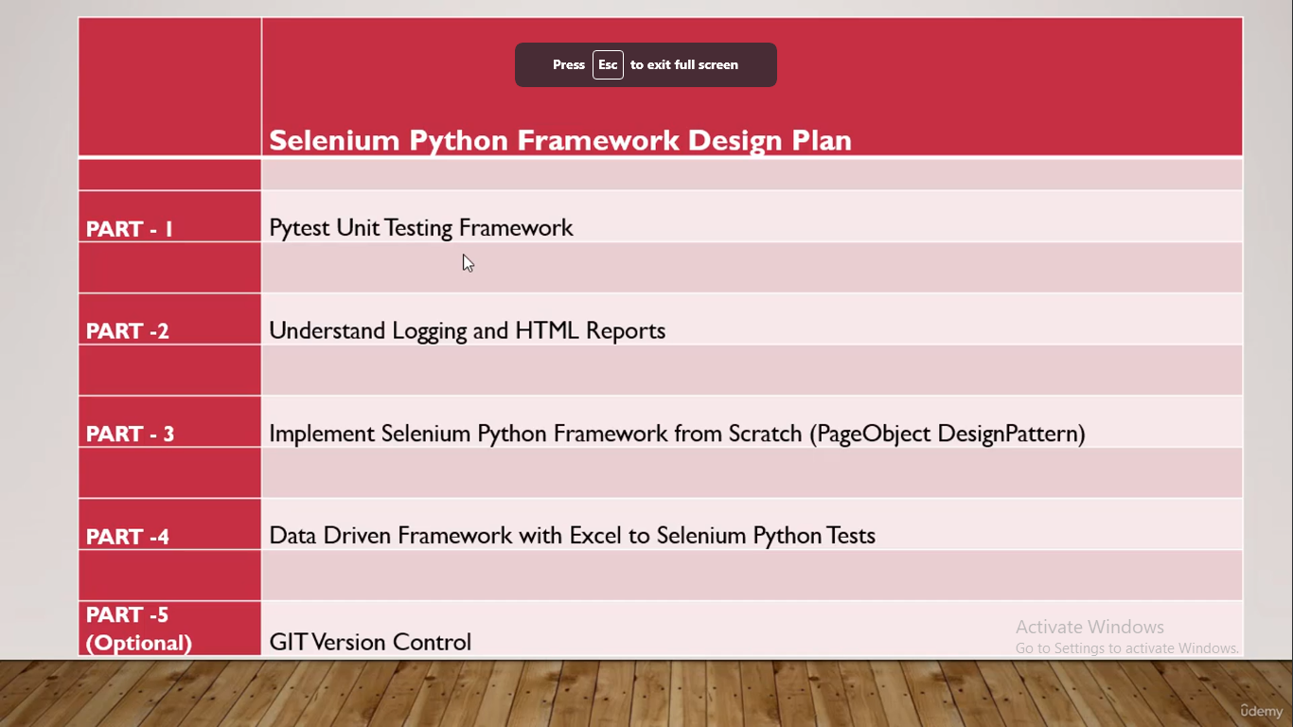

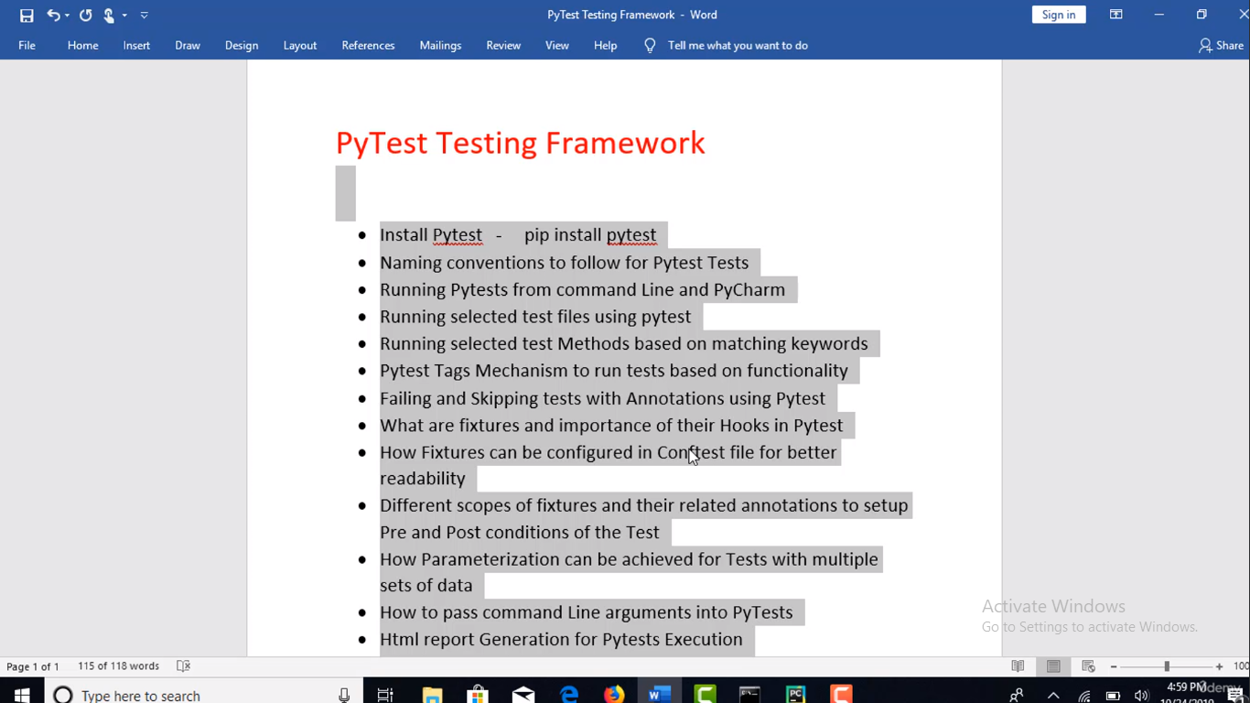

First program using Pytest

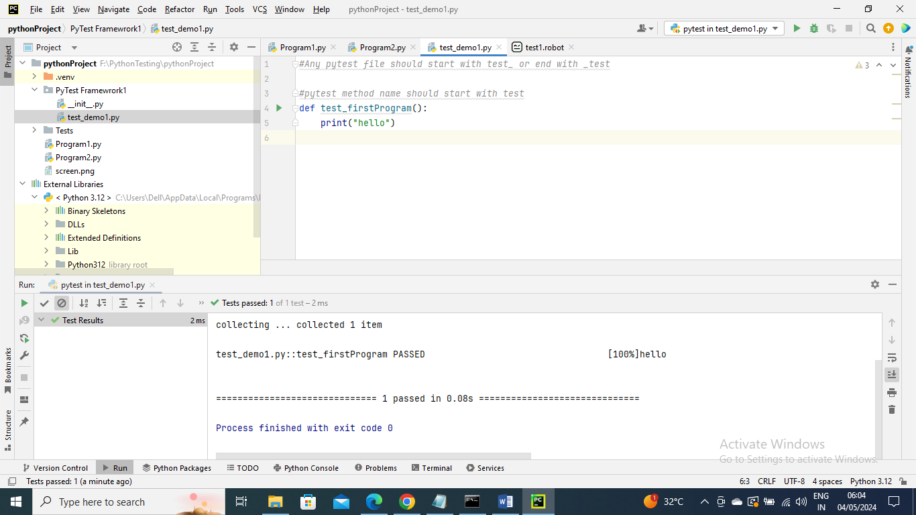

Now to run this pytest go to “Edit Configurations”

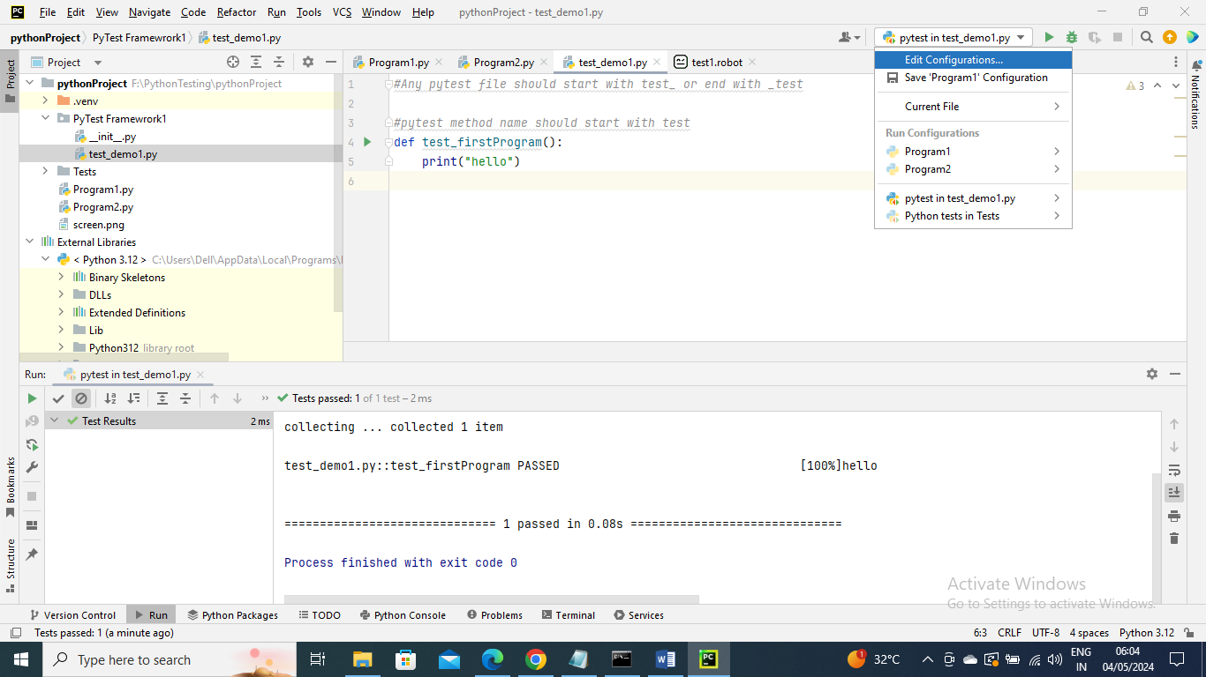

Add Pytest and apply

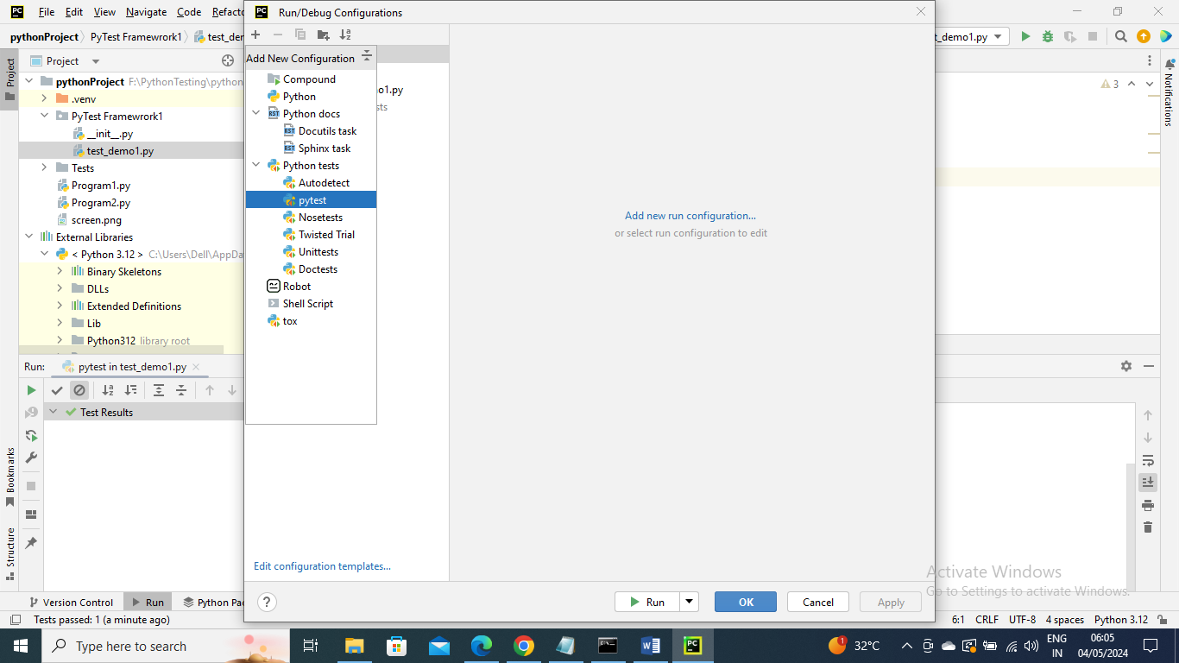

Now again go to “Edit configuration” and provide the script path (i.e. you pytest program)

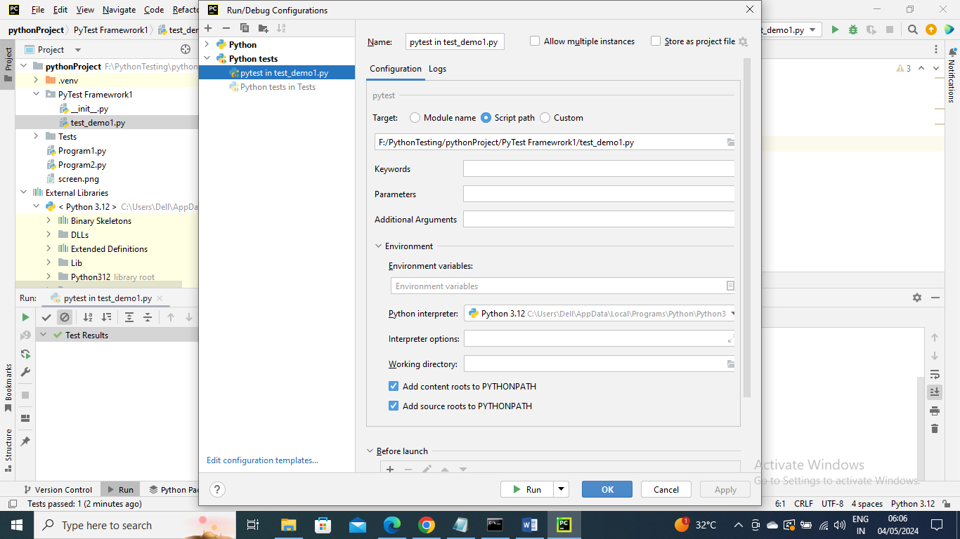

Now you can run it and as you can see it ran successfully

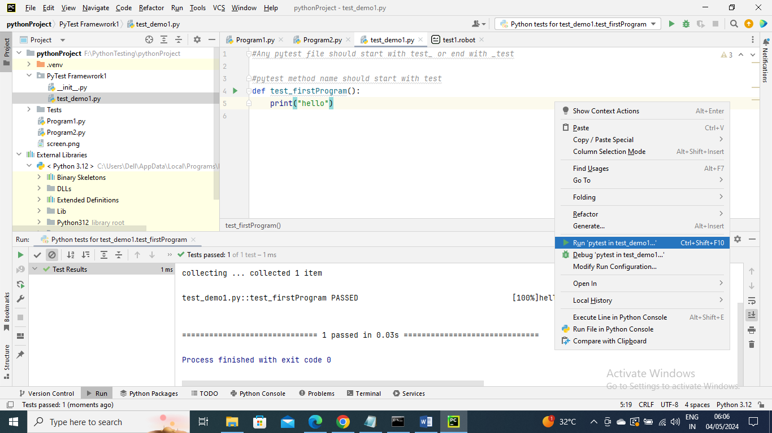

----------

Running the pytest using terminal:

Program

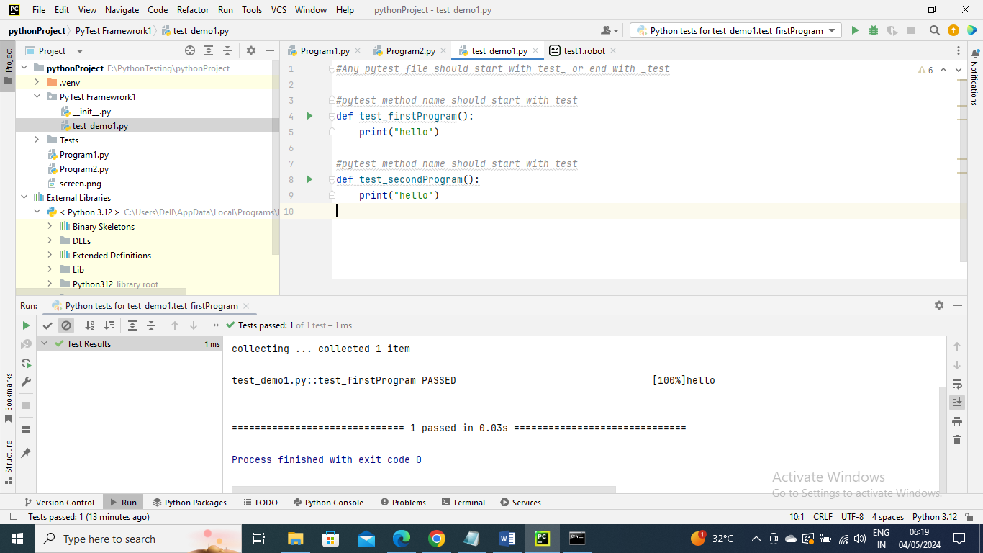

Got to package folder where pytest program are written

The below command gives just information of all pytest that are picked all that methods inside it are run

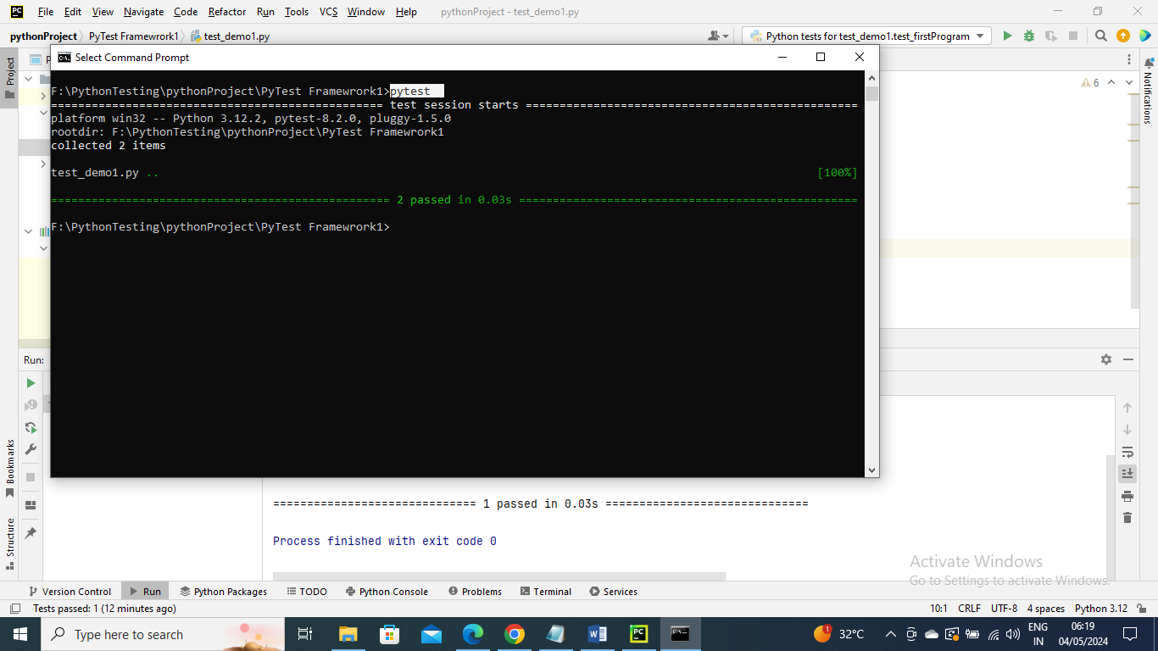

To see which method has been run we can use –v here v means verbrose

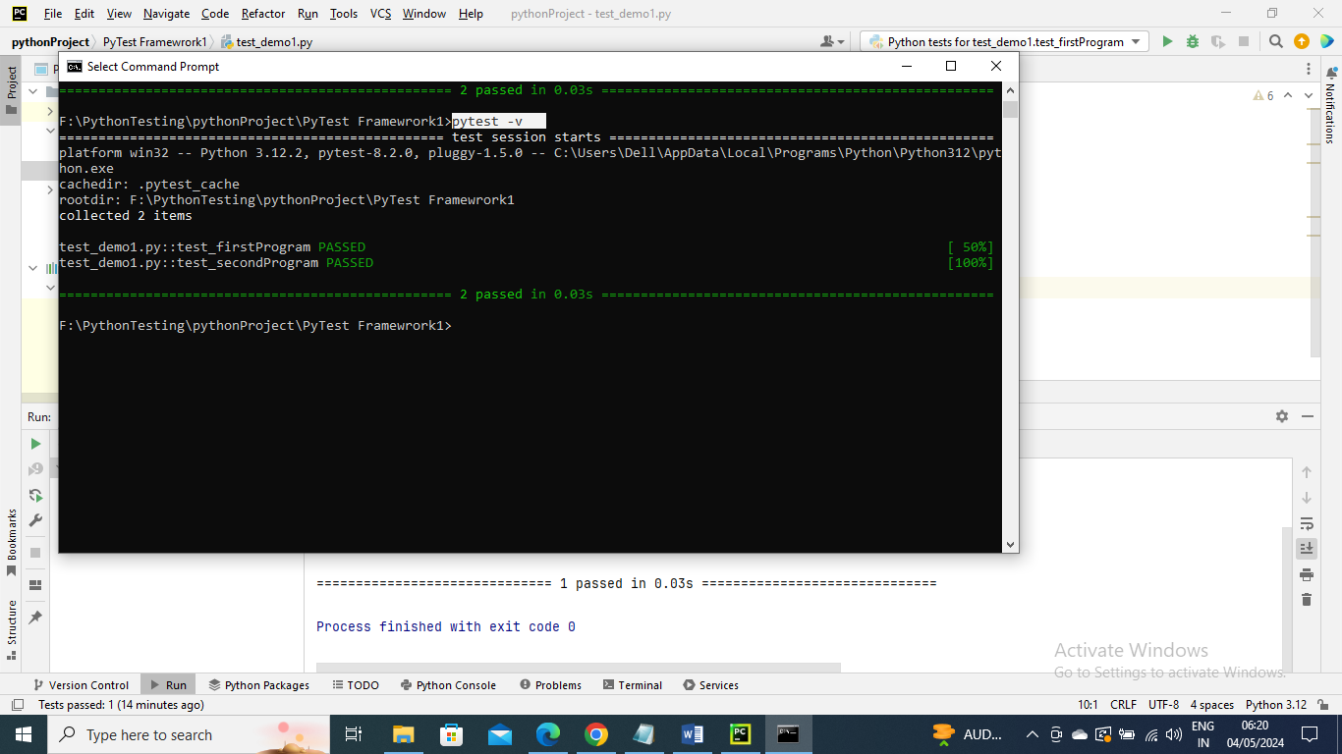

But in above we didn’t get print data to get that we need to give –s . So to get print info we need to give –s

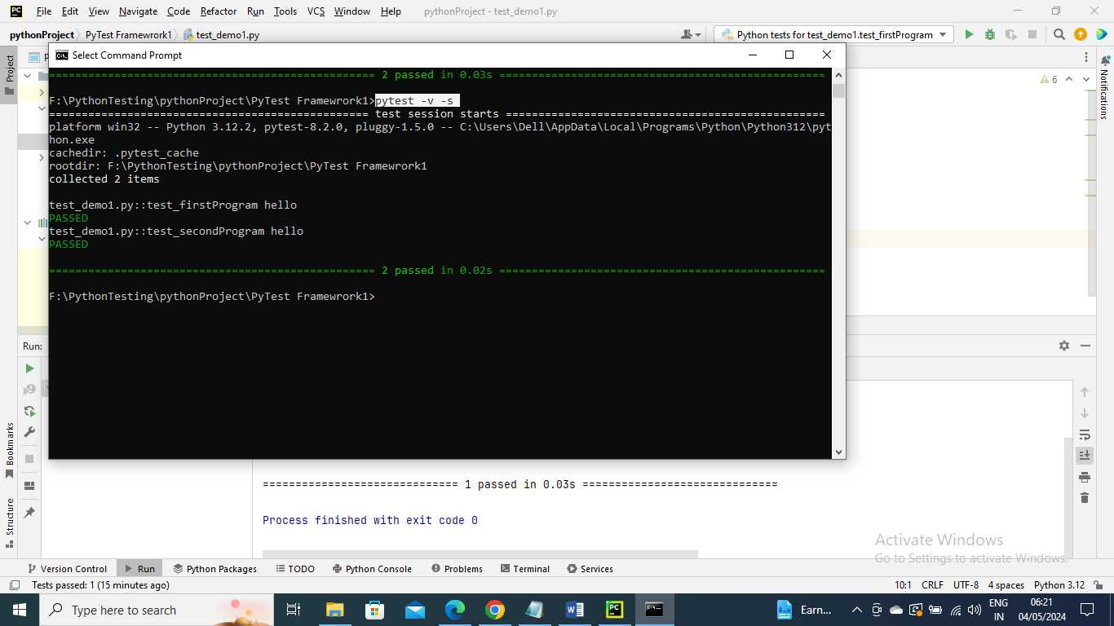

-----------------

Since we know that the command pytest will pick all the pytest programs and run it so let’s create another program which will have two methods and second method we will fail intentionally to see fail info

Program

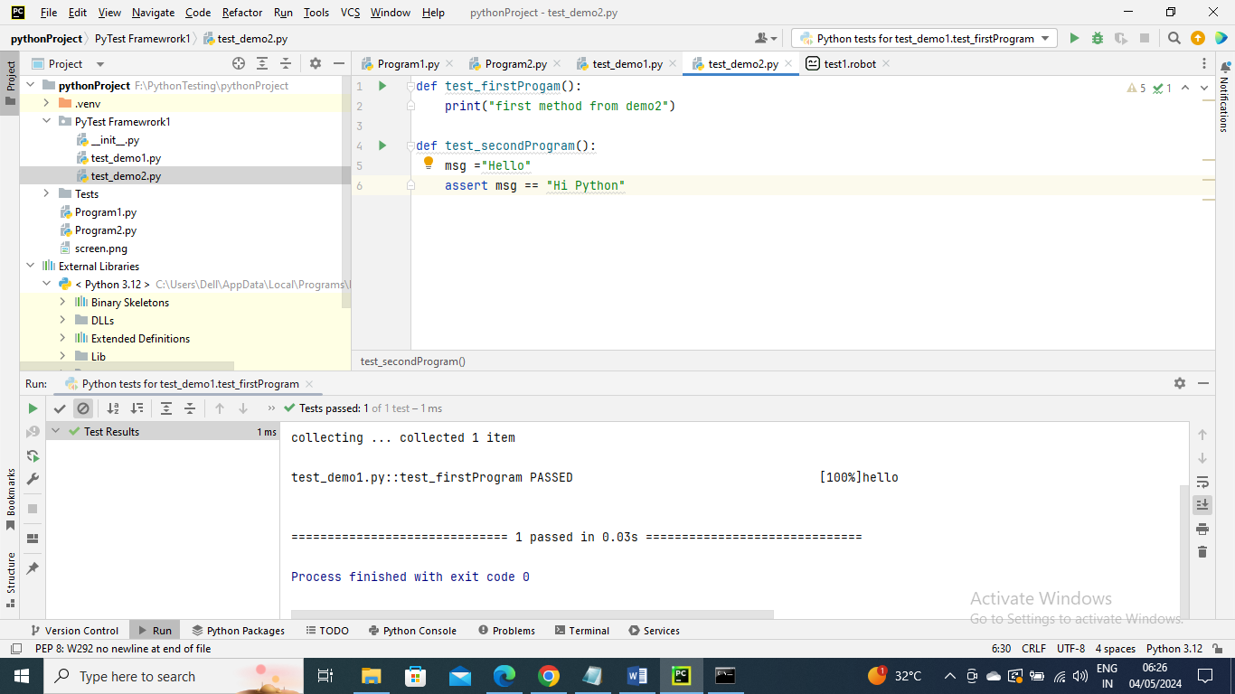

Command run – And as expected 3 passed and 1 failed

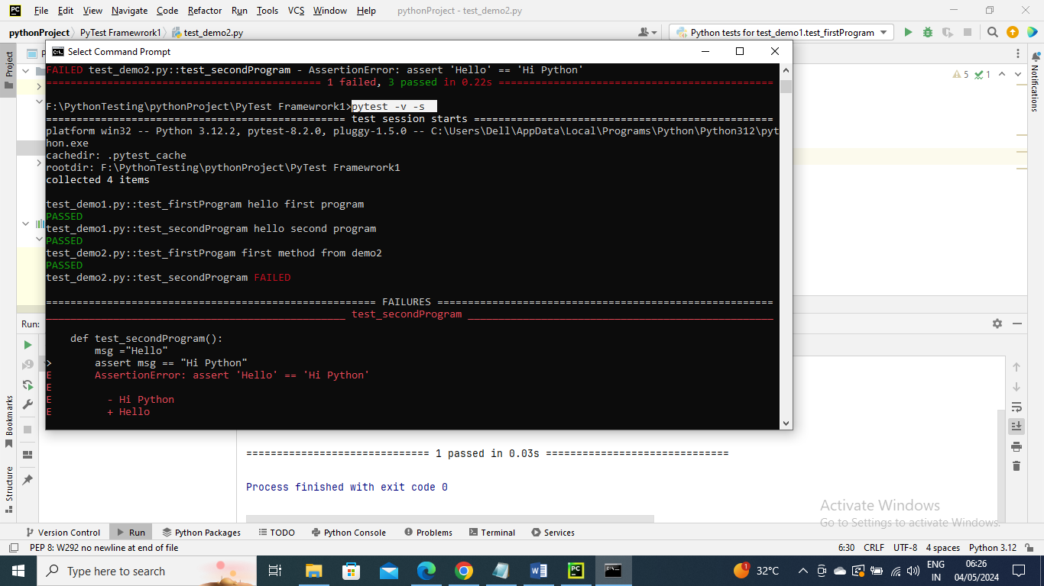

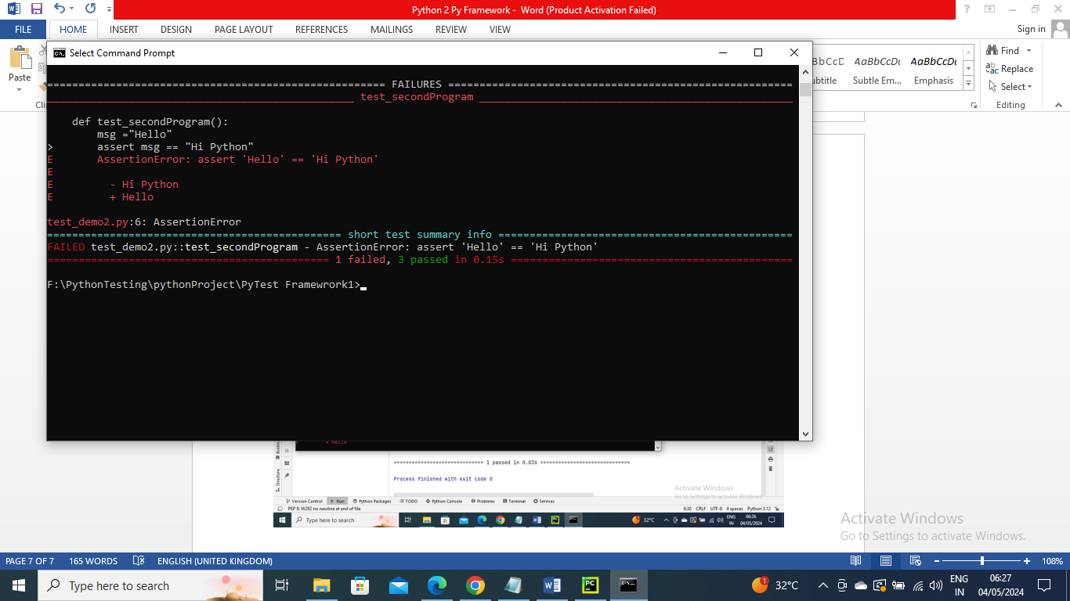

----------------------------------------

Now let’s say you don’t want to run all pytest programs and you want to run specific one you can do as below

As you can see only test_demo2 program ran

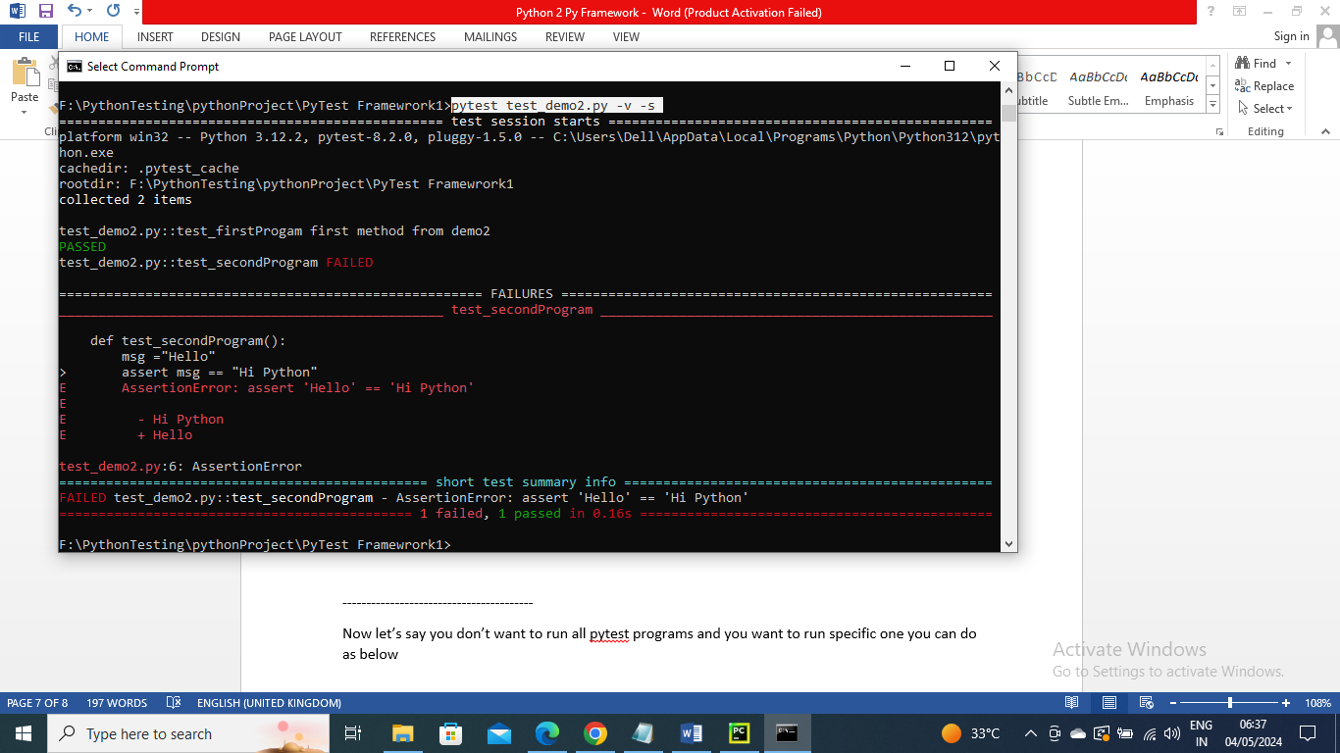

---------------

Now let’s say you want to run a specific method which contains second work in the methods and you want to run them from all programs you can do as below

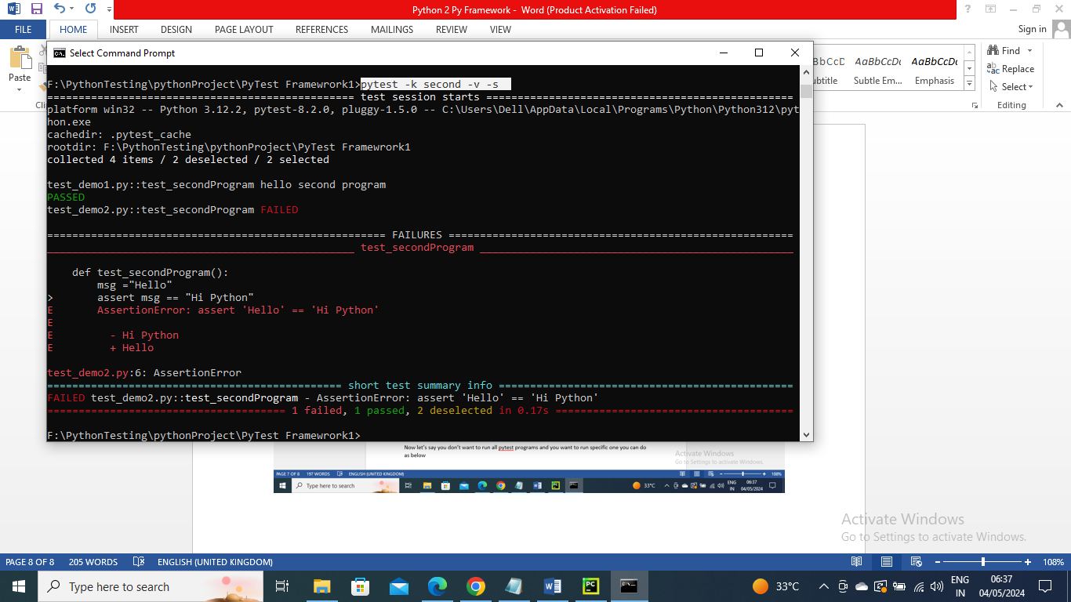

-----------

Now let’s say you want to run specific method only from one program you can do below

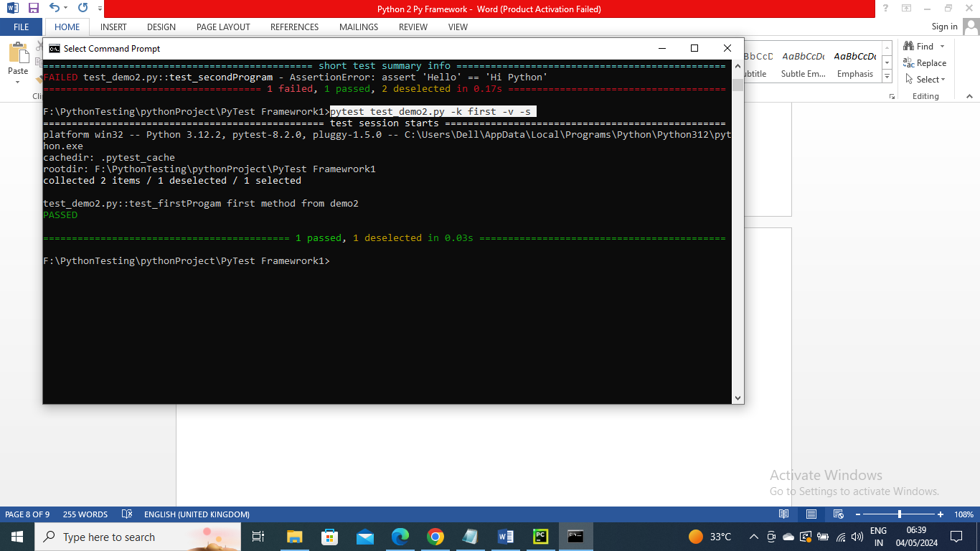

----------------

Now let’s say there are multiple pytest programs in a package say demo1, demo2 and demo3 and you want to run only demo2 and demo3 you can do using below

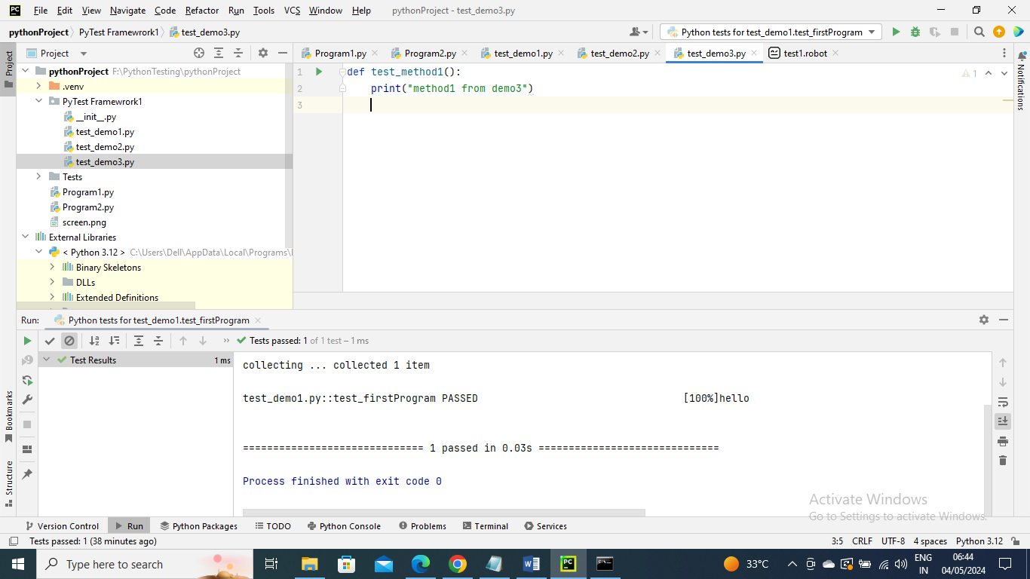

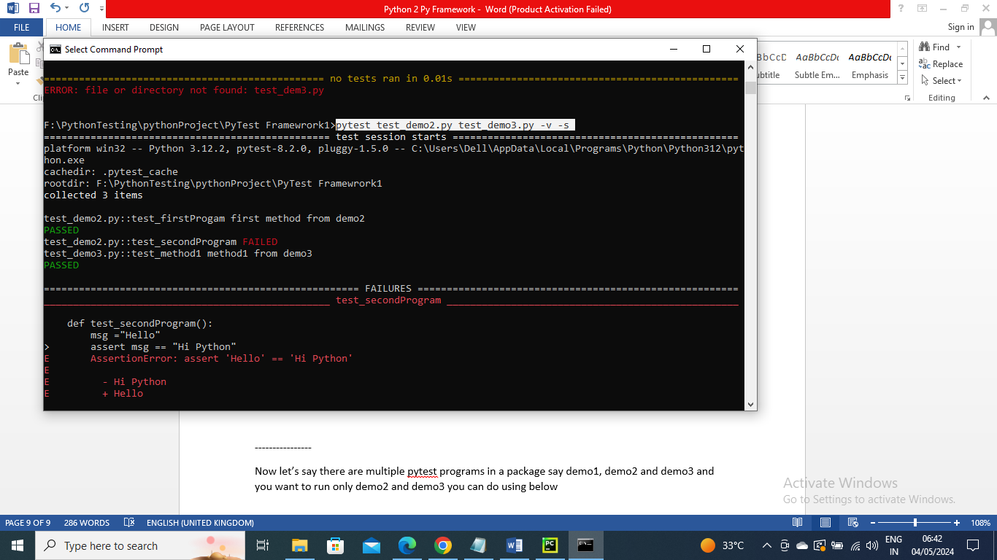

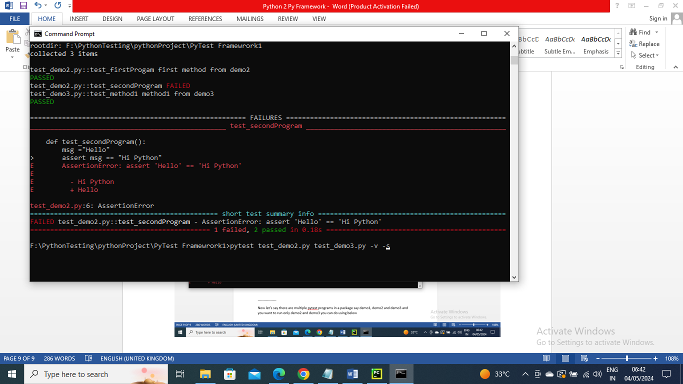

-----------------

Now let’s say there are multiple pytest programs in a package say demo1, demo2 and demo3 and you want to run only demo2 and demo3 and that contain method name as first you can do using below

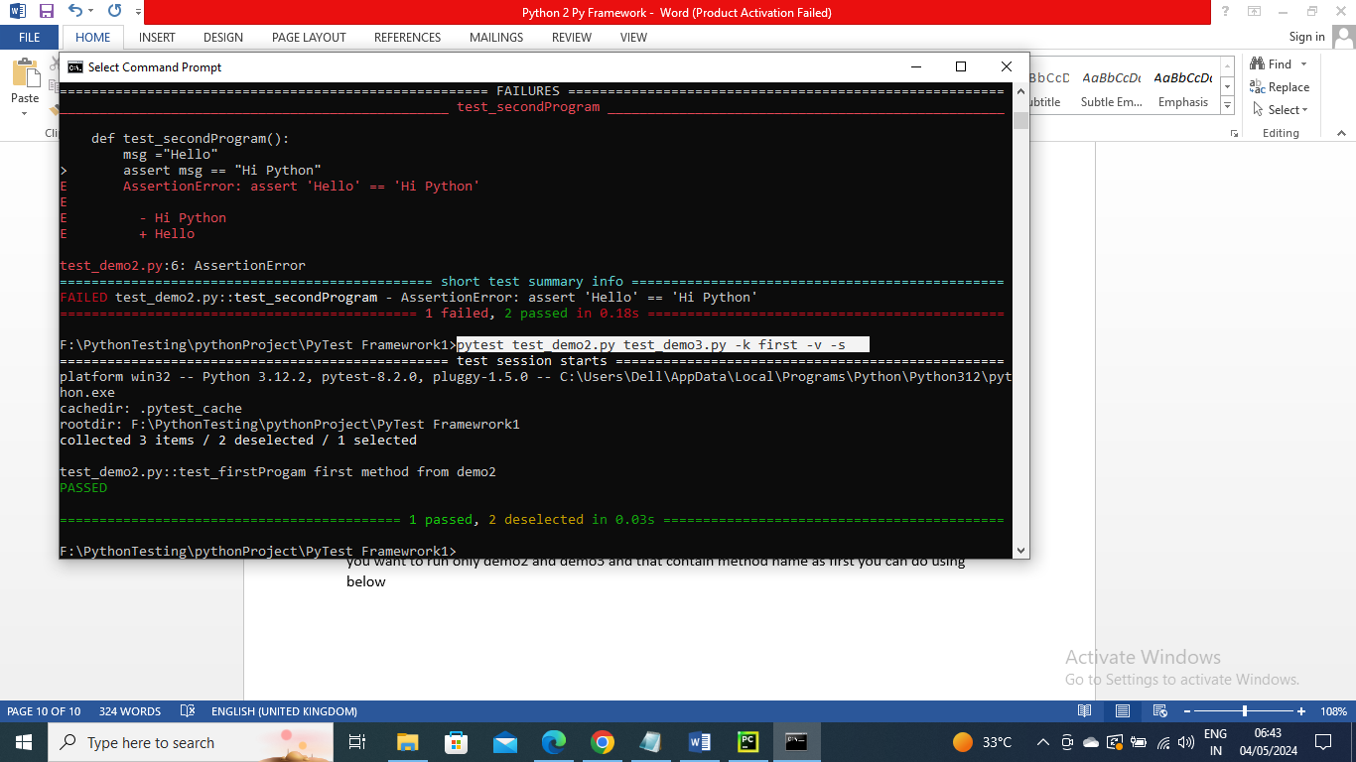

----------------------

Let’s say you want to run only some particular methods from diferrent pytest program you can mark then with a name say smoke and mentioned in command to run only them. This type of marking comes important where method names for testing doesn’t have common name to use keyword

For simplicity I just done using a single program for understanding…You can have this marked for a different methods in different program under same package and run it

Program

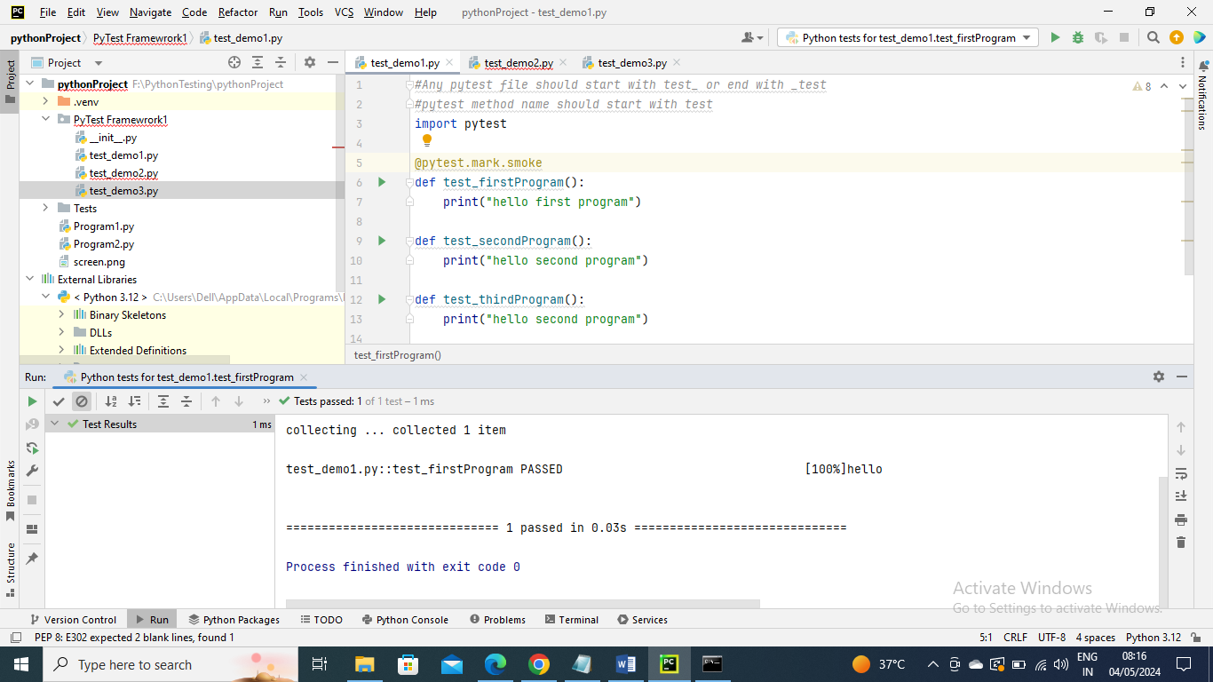

Run the command by providing mark name

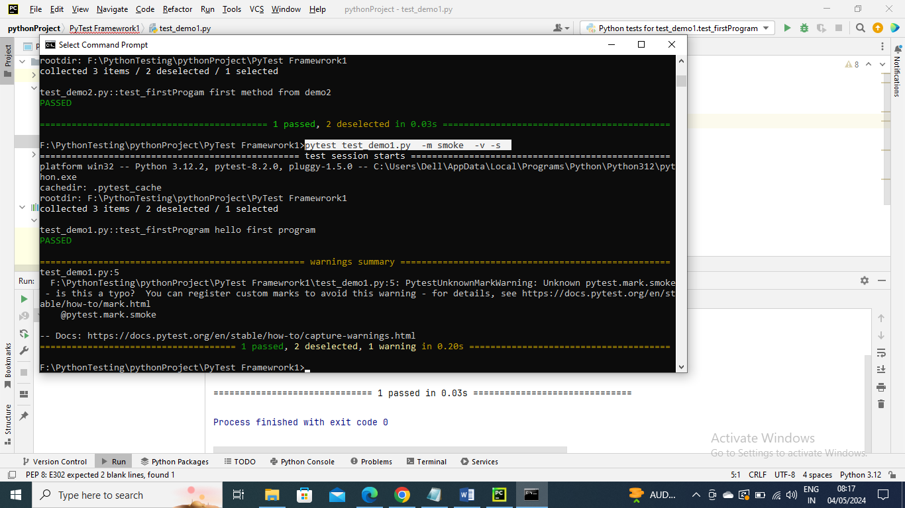

------------------------

Say you want to skip certain method you can mark with them inbuilt skip and run it

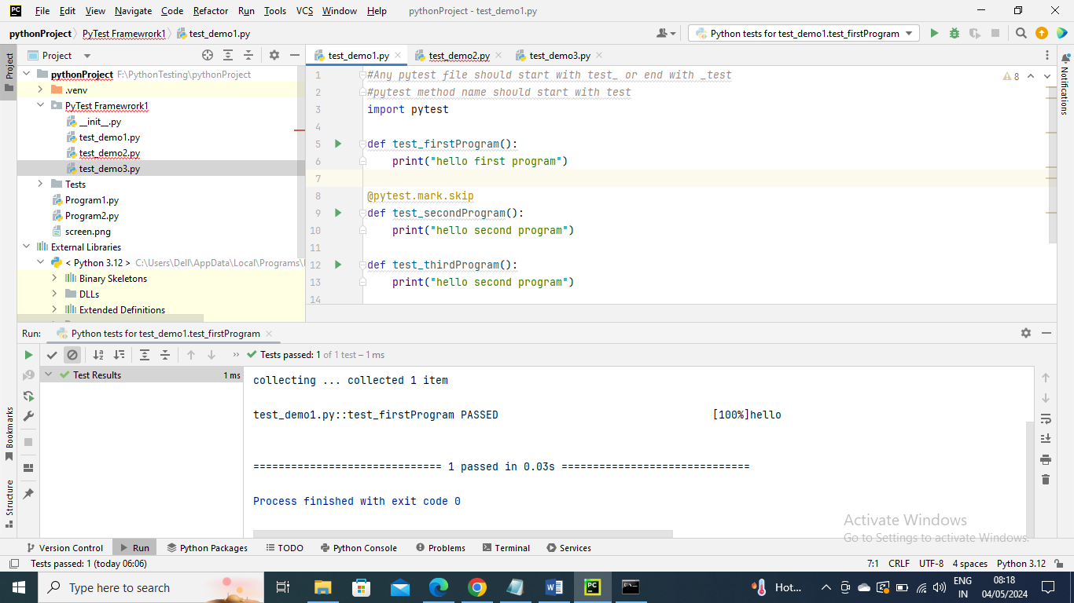

Run the command and you don’t need to give any mark name since skipis an inbuilt one

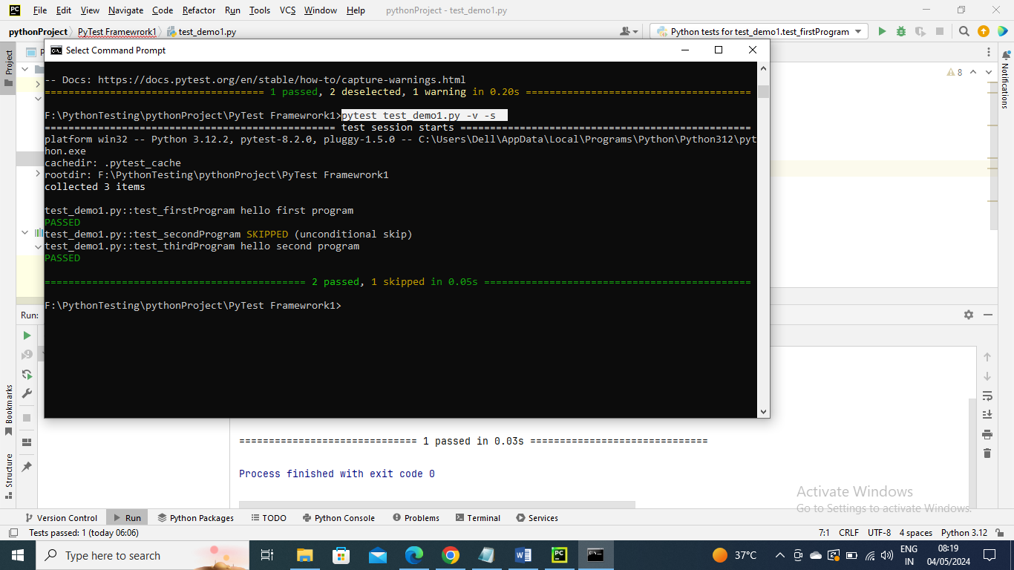

-------------

Let’s say you have one method and it gets passed and sometimes failed but that doesn’t matter to you then in that case you can make it as xfail and the output doesn’t show whether it is failed or passed it will just show as xfail

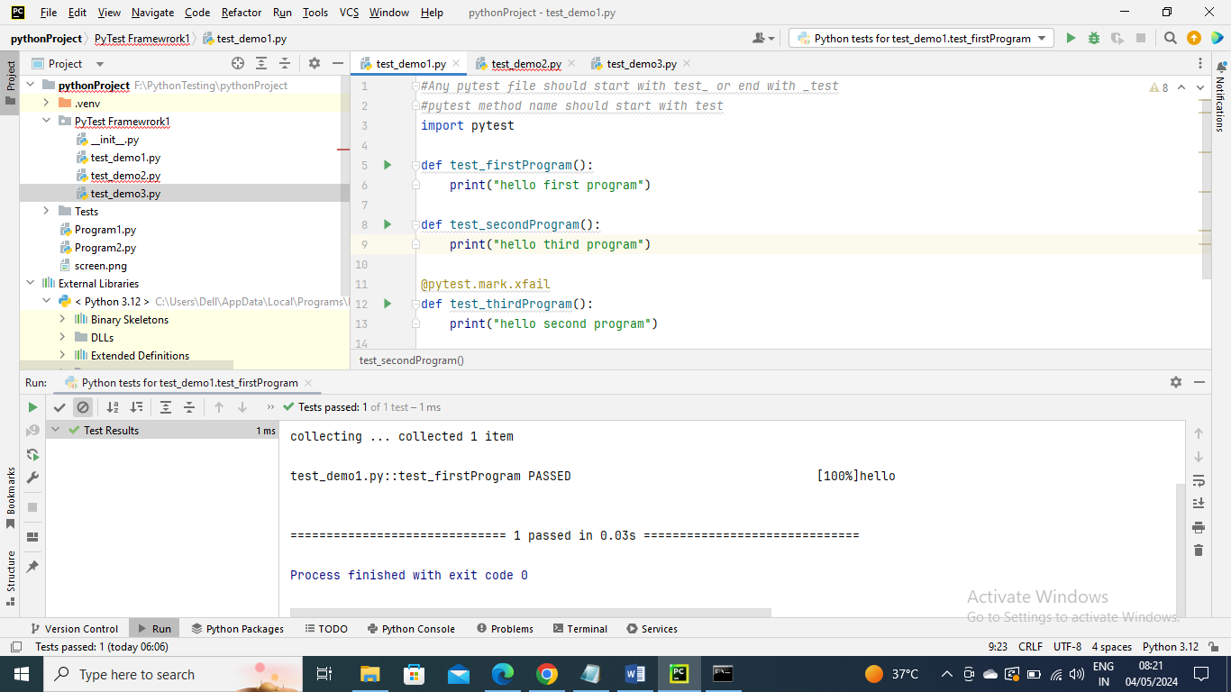

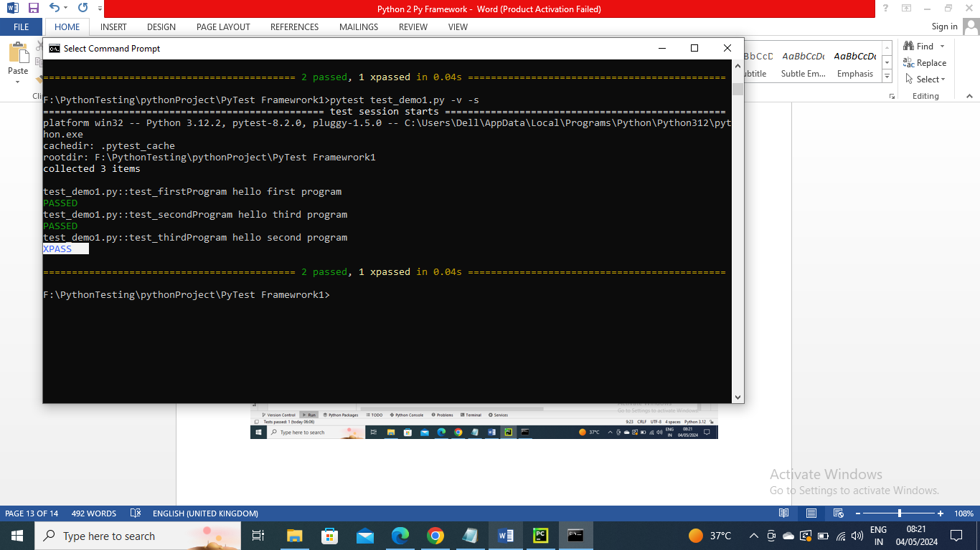

---------------------------

In Java TestNG we have @BeforeMethod and @AfterMethodsay where we run certain steps before and after method like opening coneection and closing connecting

Just in Python Py framework we have fixtures and it gets executed for each method where it is mentioned in paramaters of method the “yield” will call the other method and after yield it will be executing last you want to have steps after is your wish not mandatory

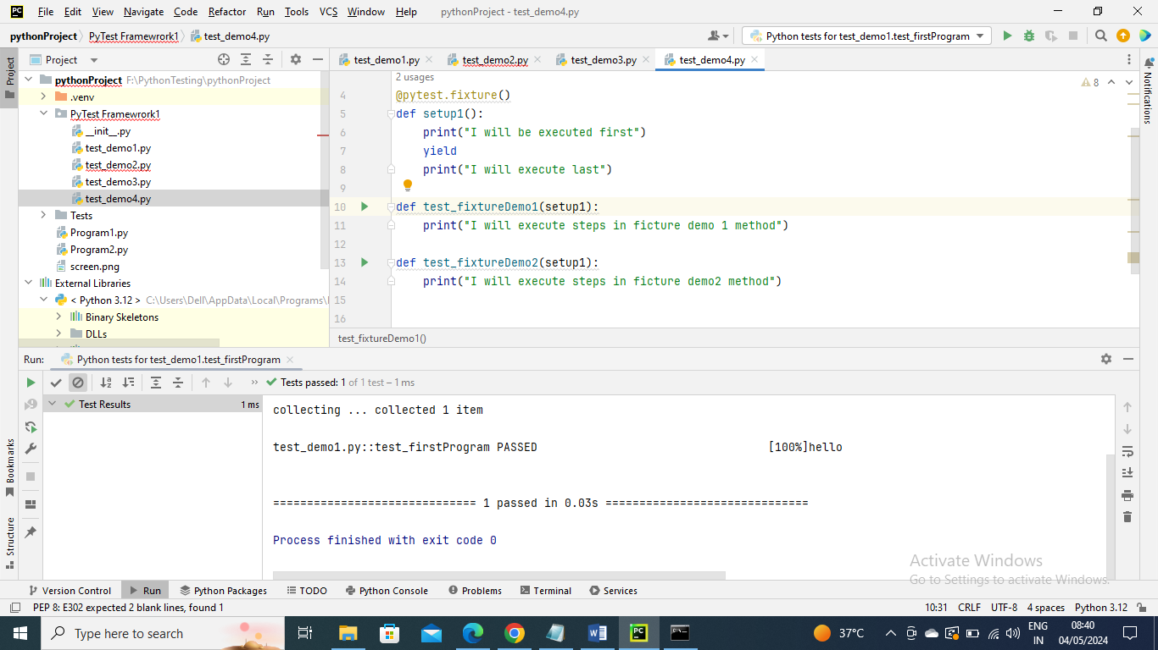

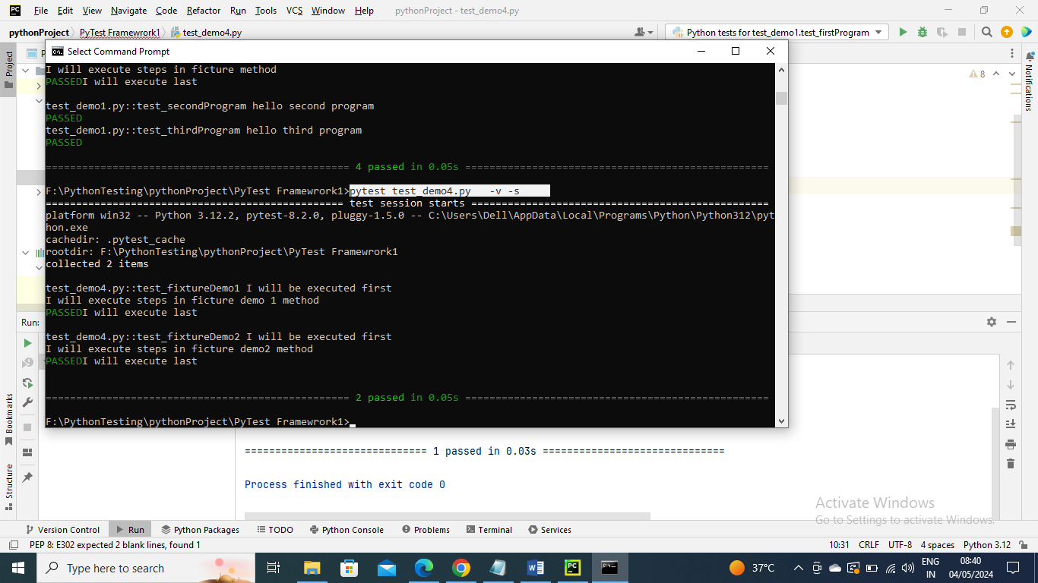

---------------

The same fixture file you can have separate py program with program name as conftest

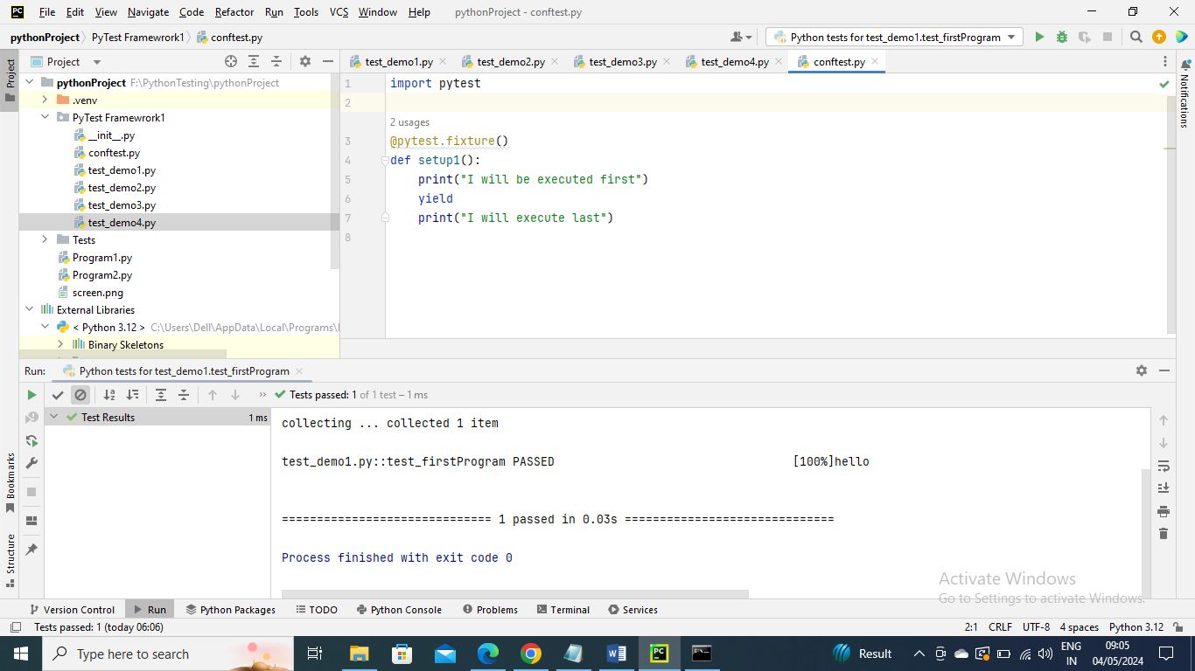

Now any program in same package….if any method has parameter then it will first check in its class for fixture and if it is not there then it will check in confttest file if that file is present

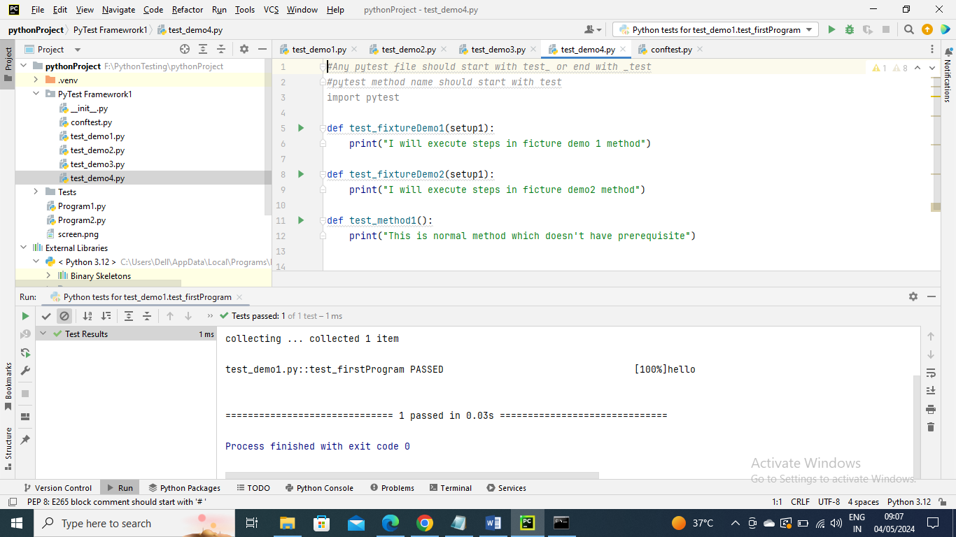

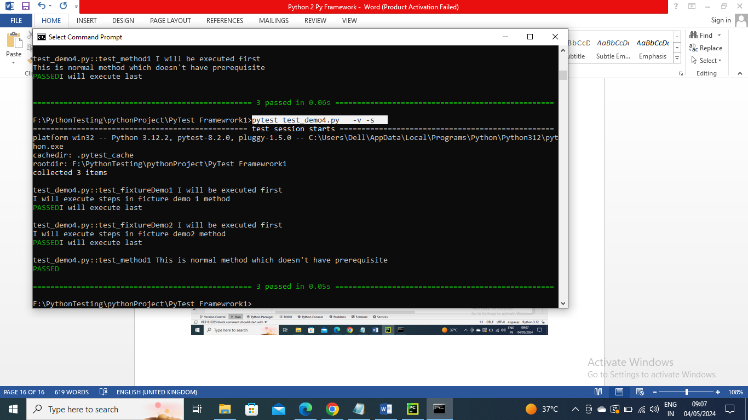

------------------------------

Now let’s say you have scenario where you need run Before and after each method the pre-requisite method and say that program has 100+ methods now you can’t manually update fixture name for all. In that case you create a class and have methods inside them as you know methods in class should self as mandatory. Now you can declare that fixture name on class level so that it is applicable to all methods

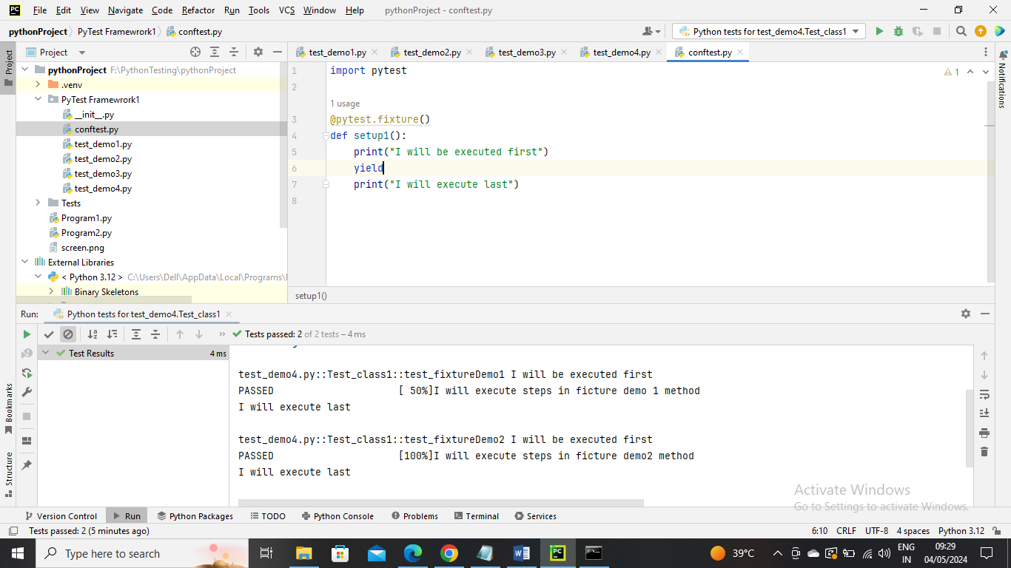

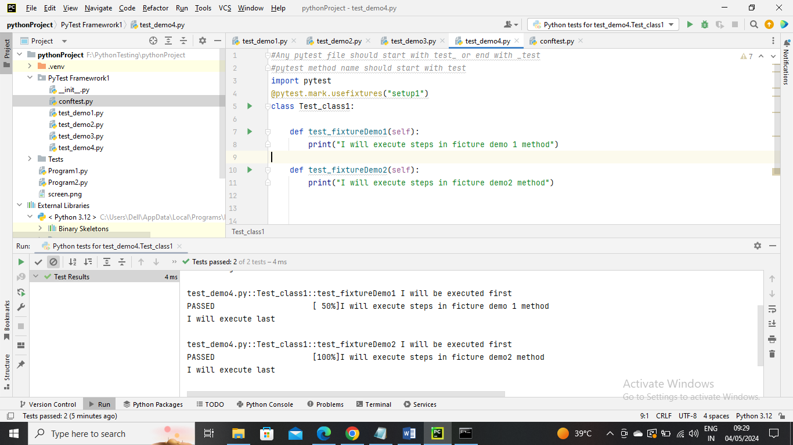

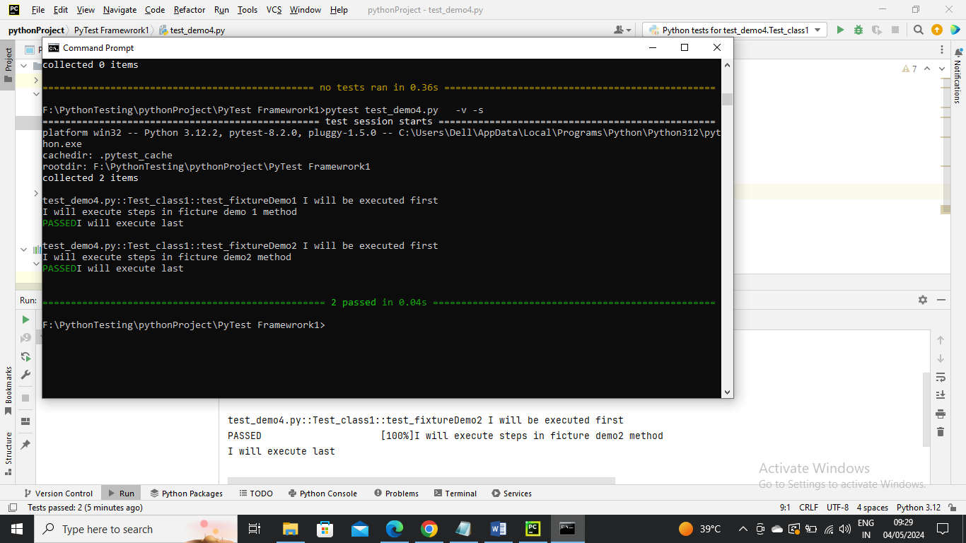

------------------

Now in above for each method it executed before and after steps in fixture …….. Say you want them executed only once at start and once at end like Before Class and After Class like testing in java….You can make the scope of fixture i.e. conftest program to “class” so that it executes only once

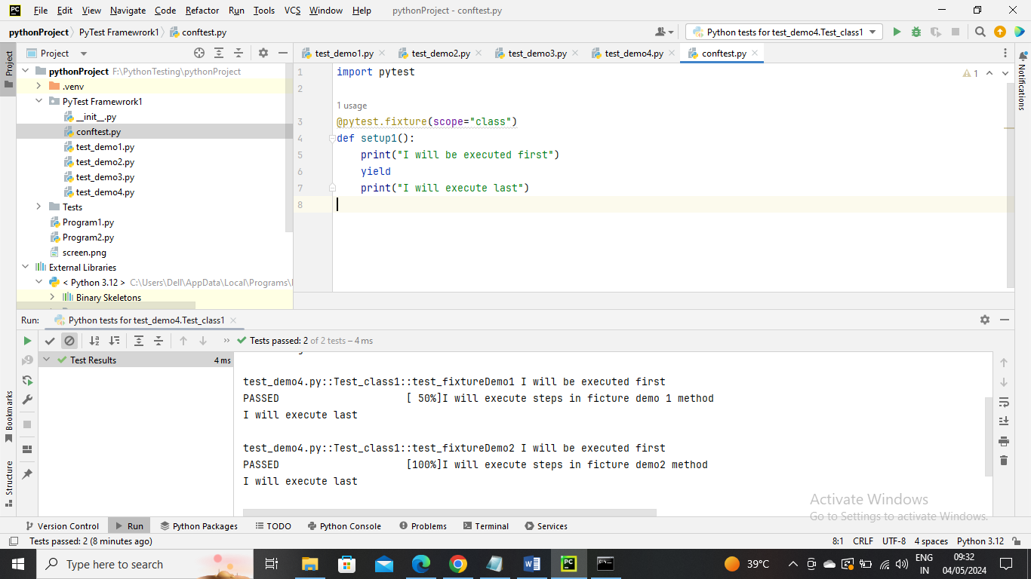

The below program is not changed

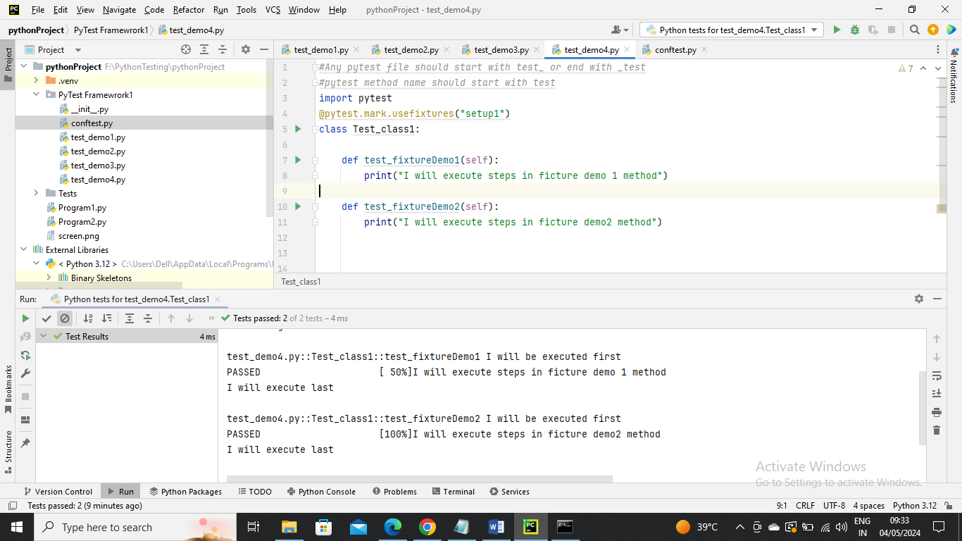

As you can see below the fixture method gets executed only once at first and once at last

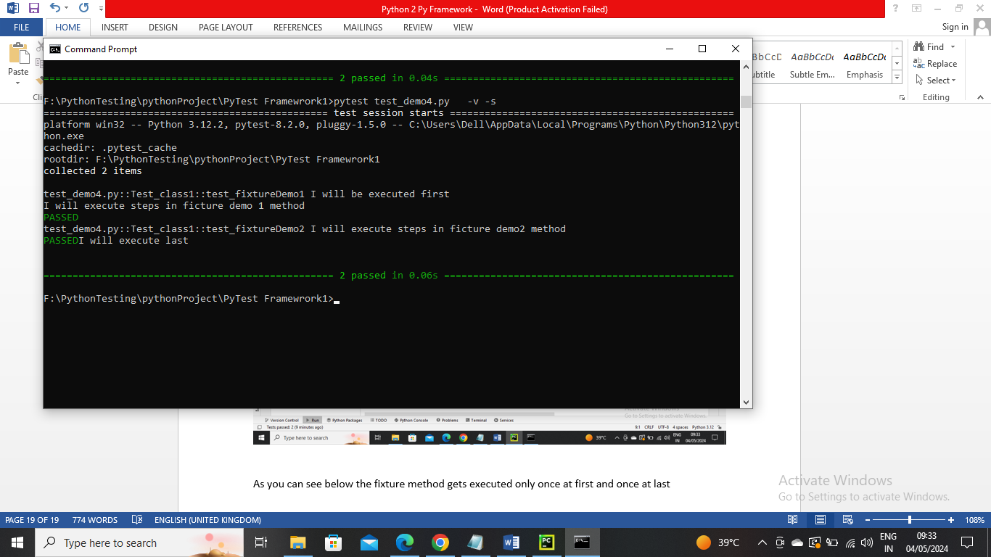

---------------------------------------

Below is an example of how to pass the data into Tests

Below is conftest file where I have created fixture method dataLoad where I mentioned some data where all methods that use this fixture can get this data

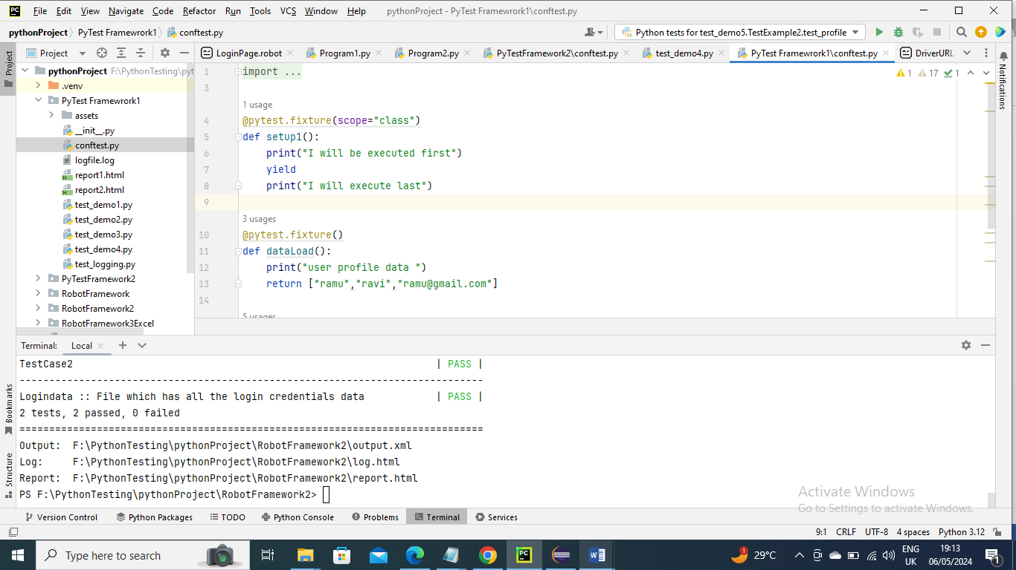s

In below program fixtureDemo2 has used DataLoad fixture and that data can be accessed

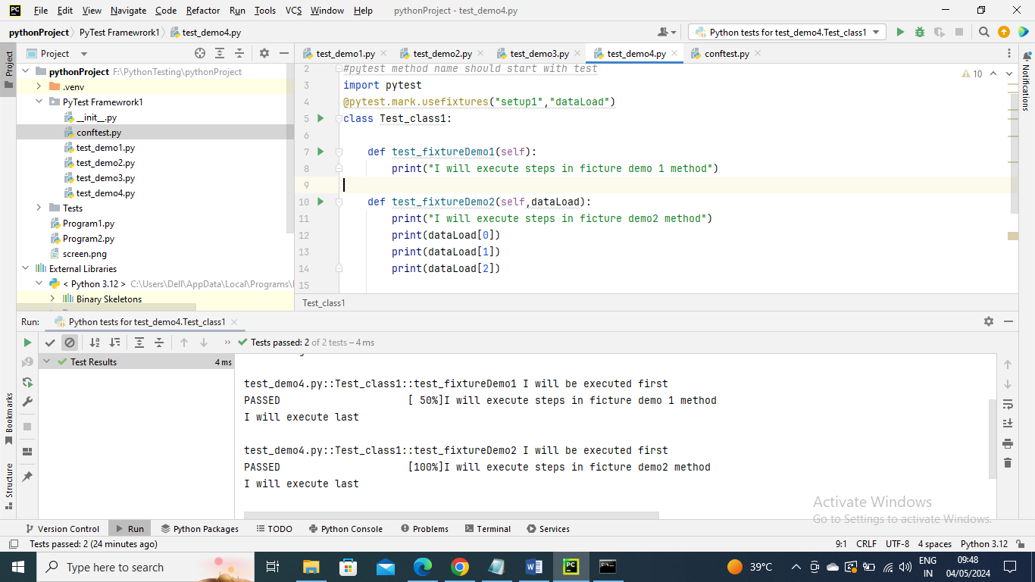

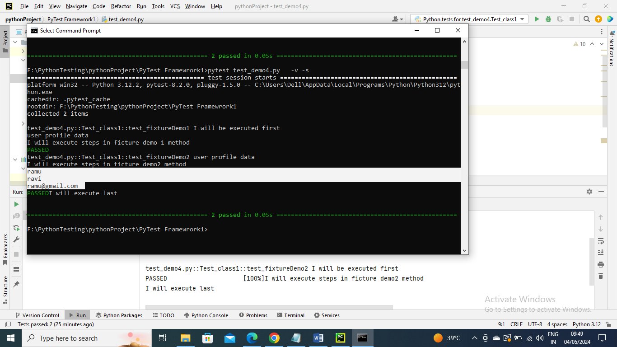

---------------------------------

Parameterizing test with Single data set

In below I have passed single data set

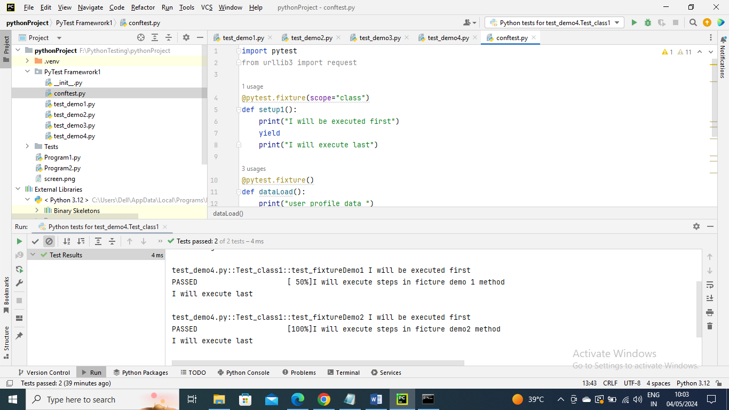

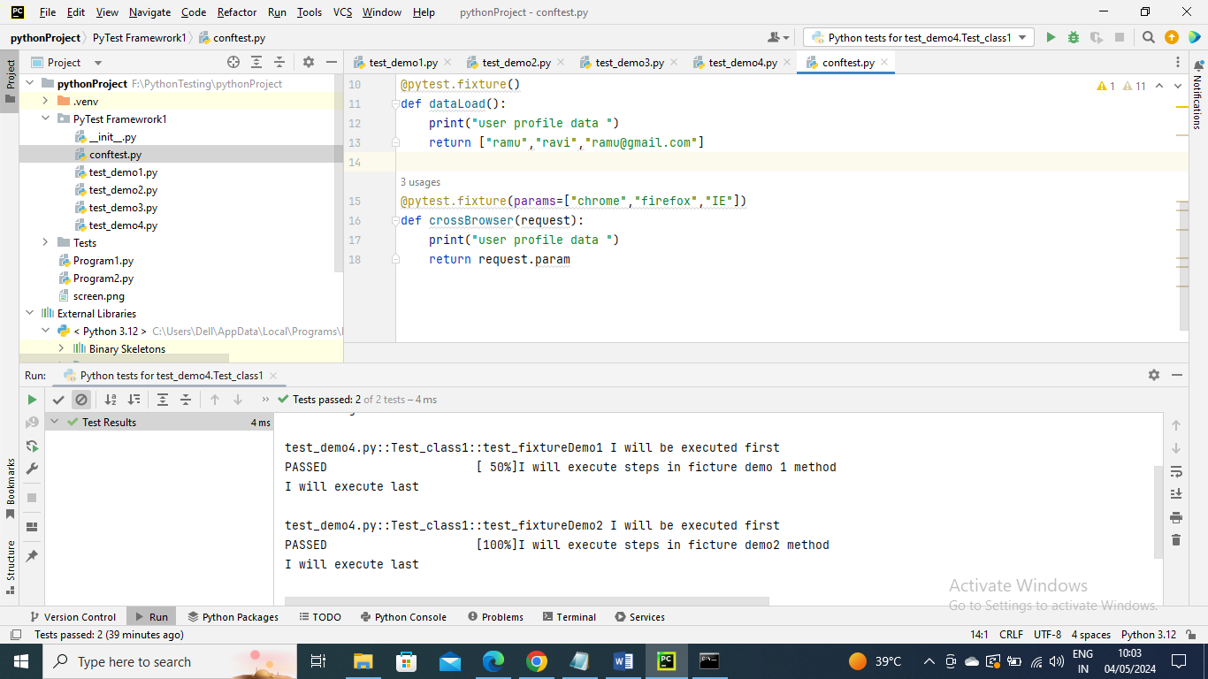

Now where this crossBrowser fixture is used it will be executed each time for each parameter since I provide three parameters it will execute separately for each parameter

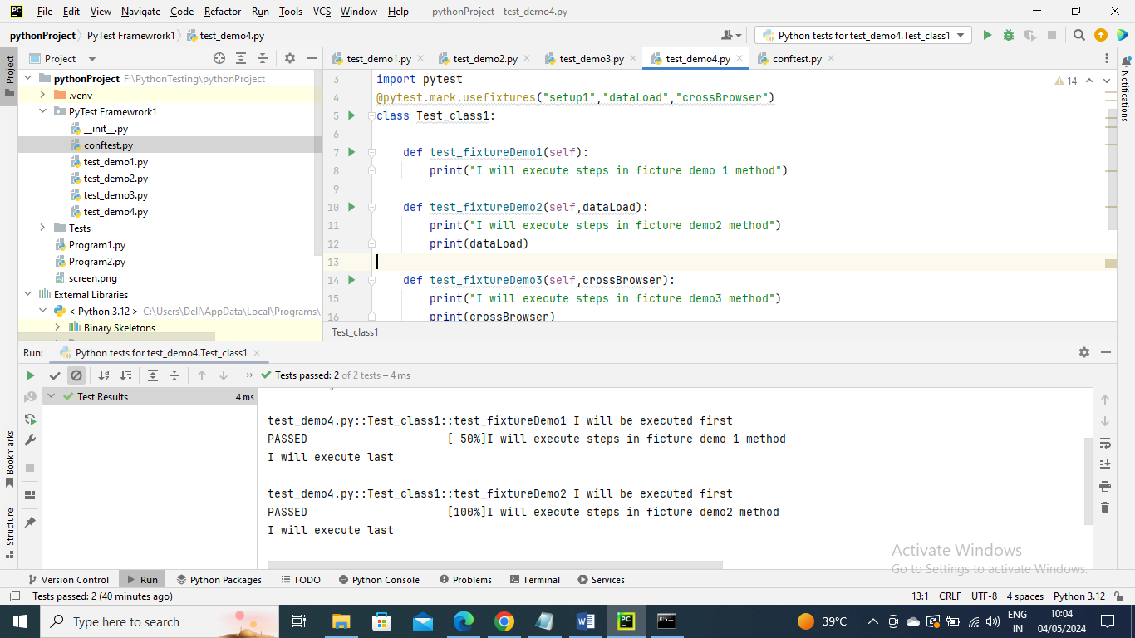

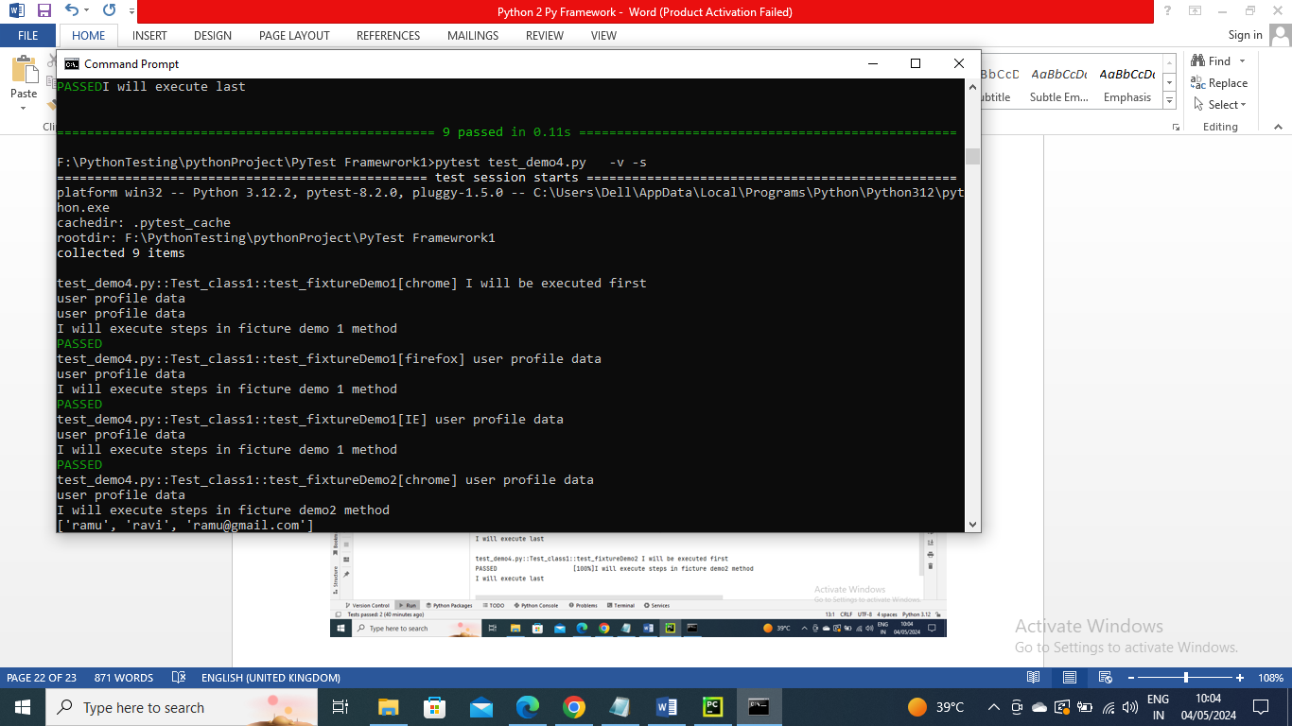

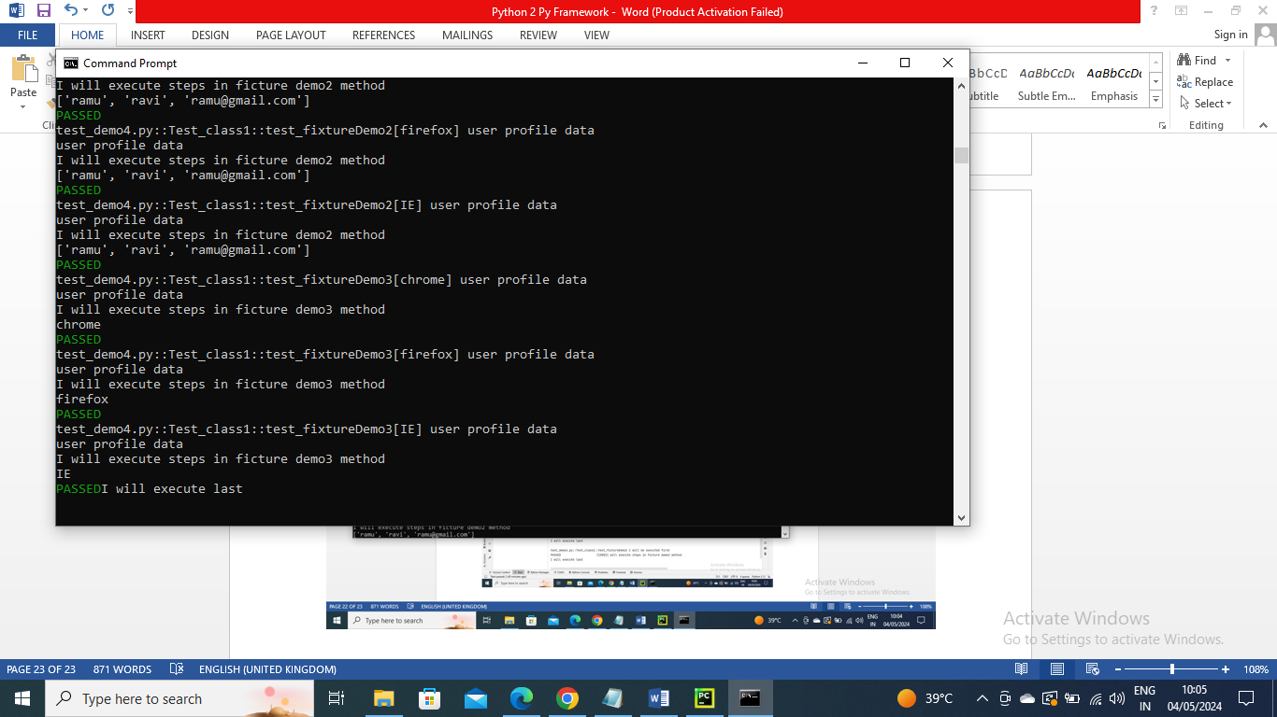

----------------------

Paramterizing test with multiple dataset

Below is an example where I have passed three values for each data set and of three paramters of each data set having three values

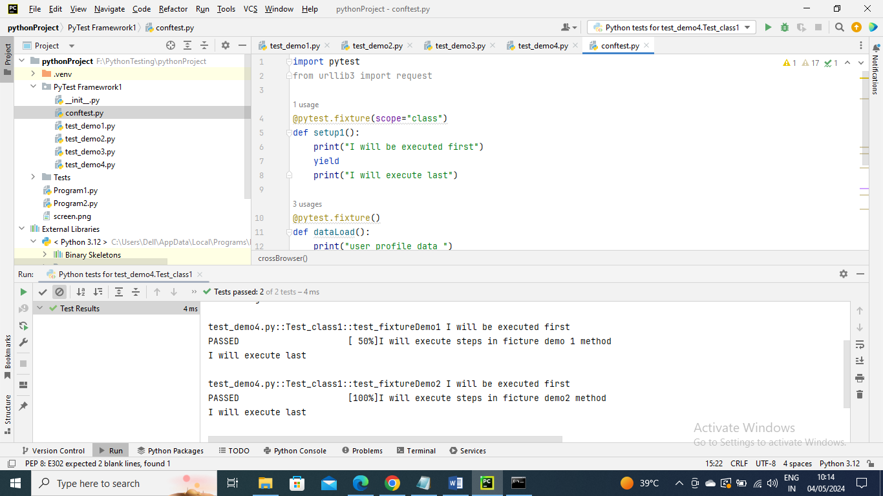

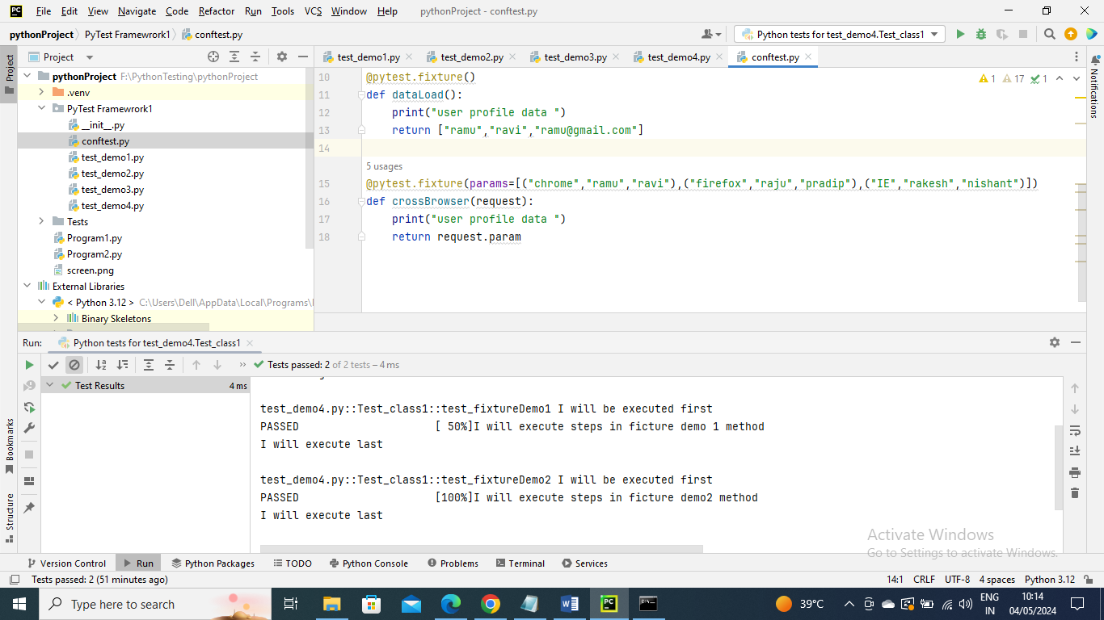

In below program I have accessed the crossBrowser data

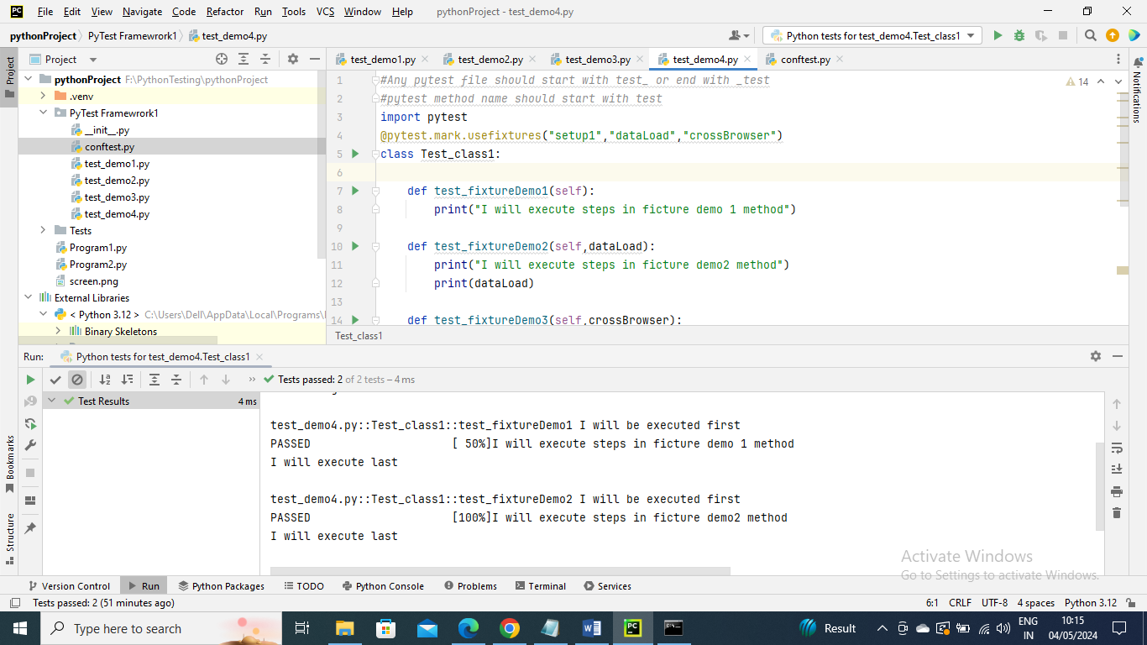

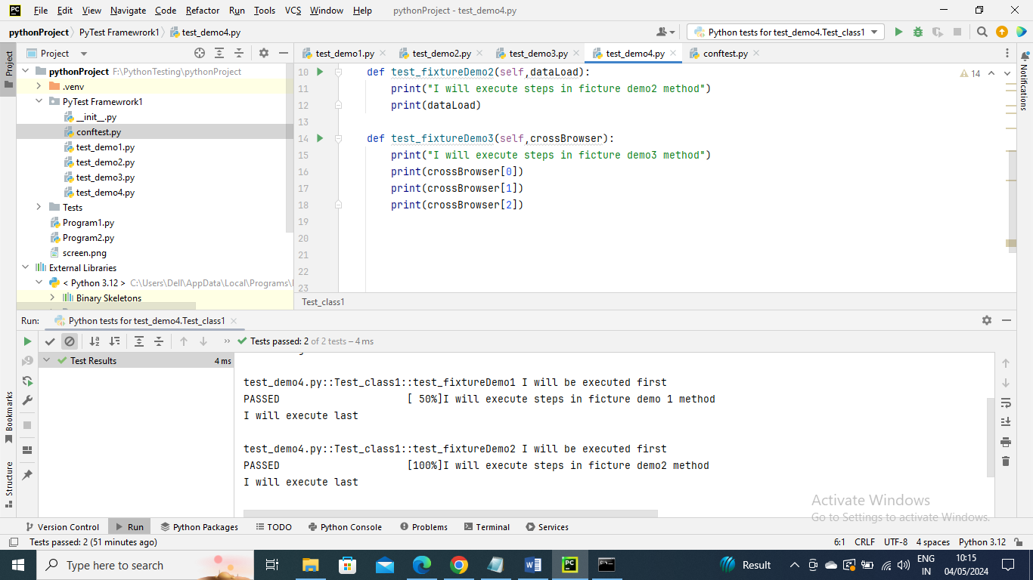

Run the command

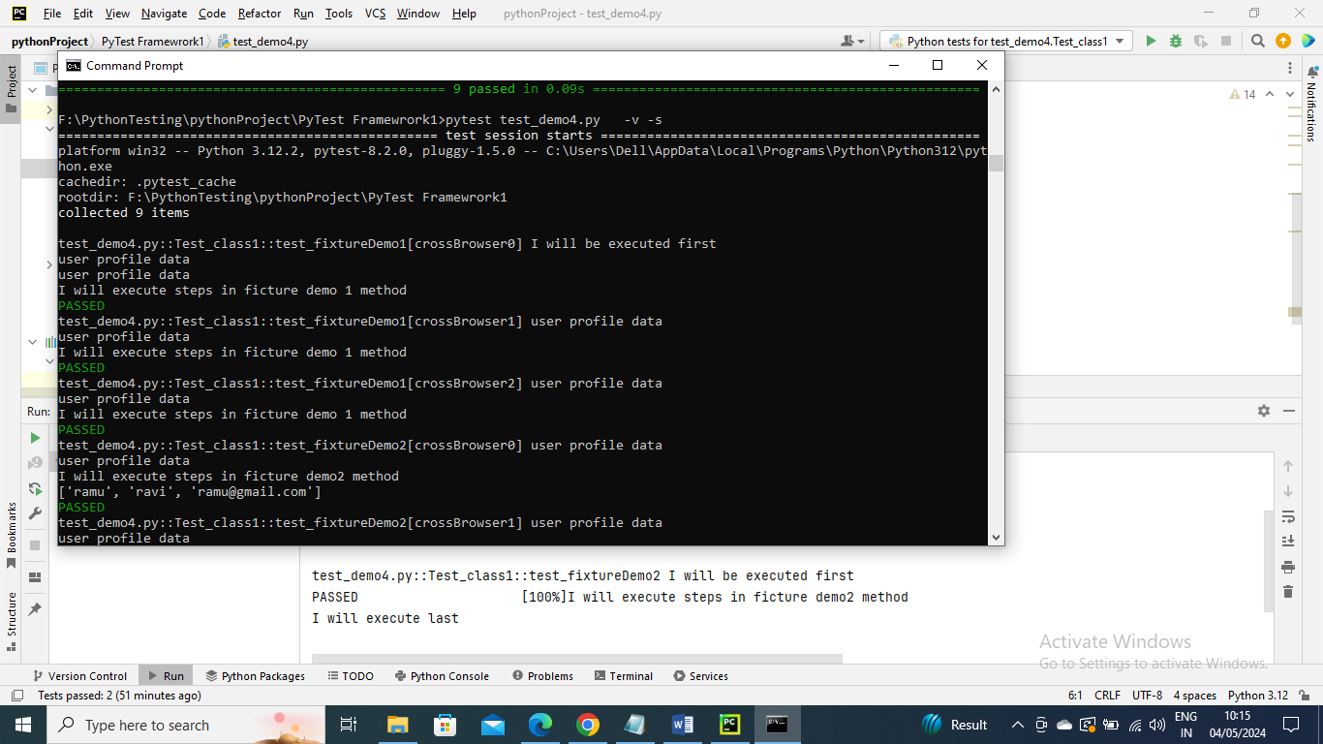

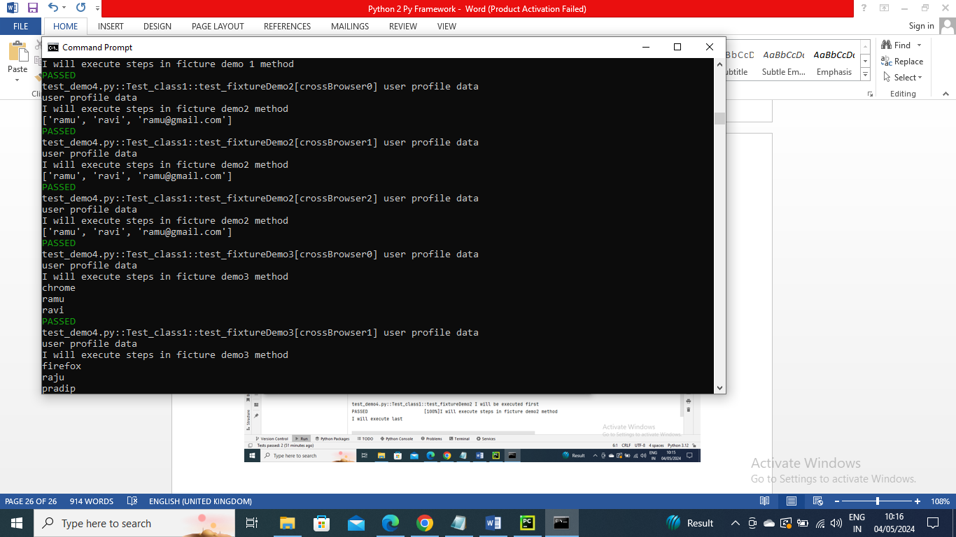

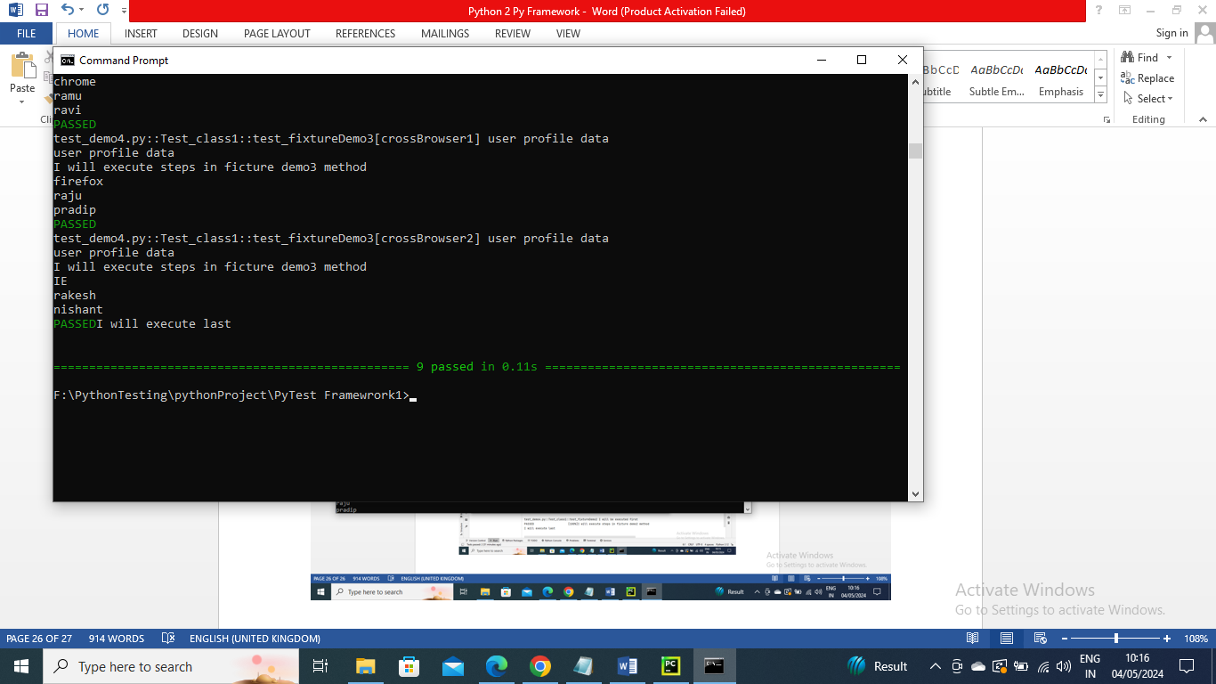

----------------------

Generating HTML reports

Install python html package

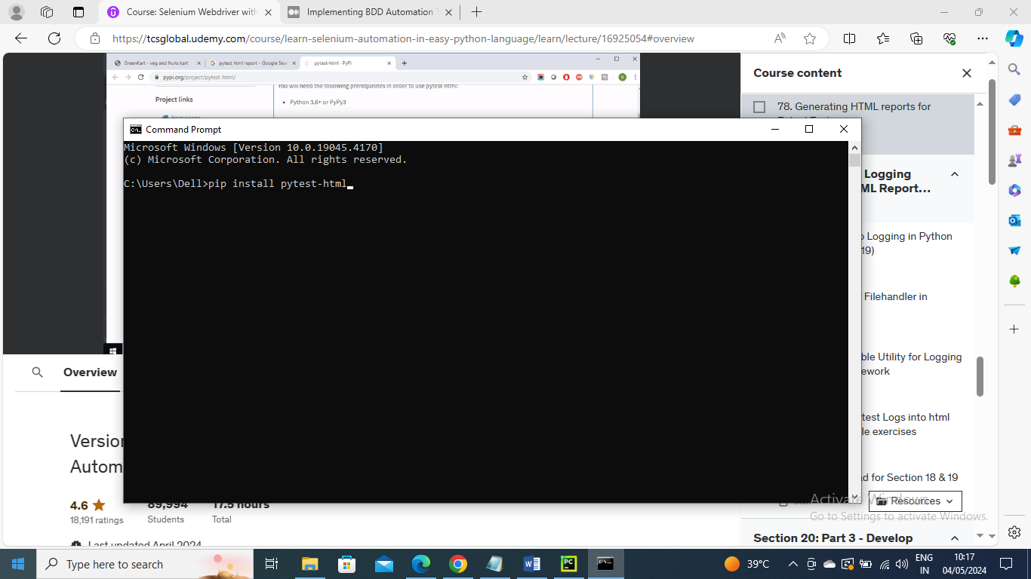

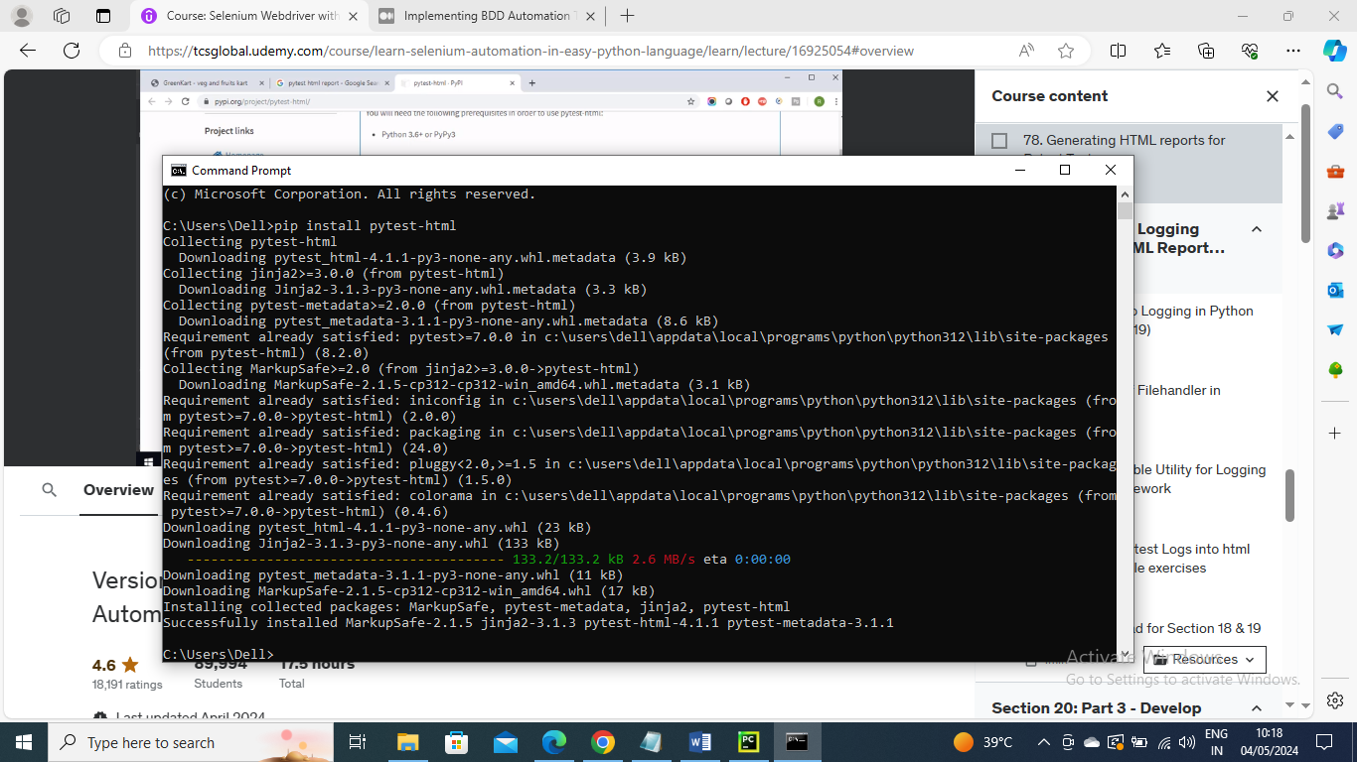

Run the below command to generate html report, the report gets created in same folder where it ran

Pytest –html=reportname.html –v -s

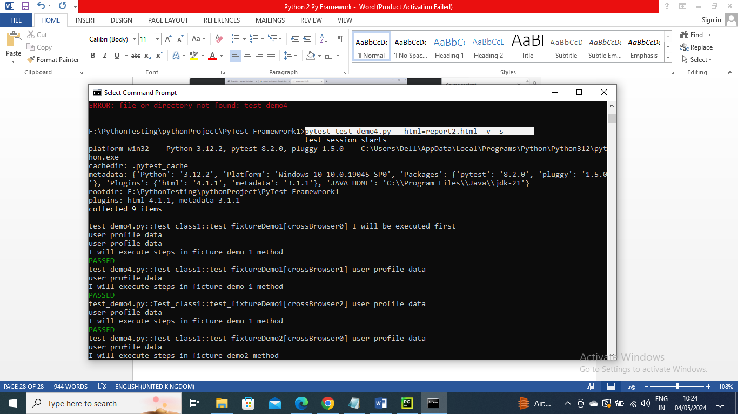

Report has been generated

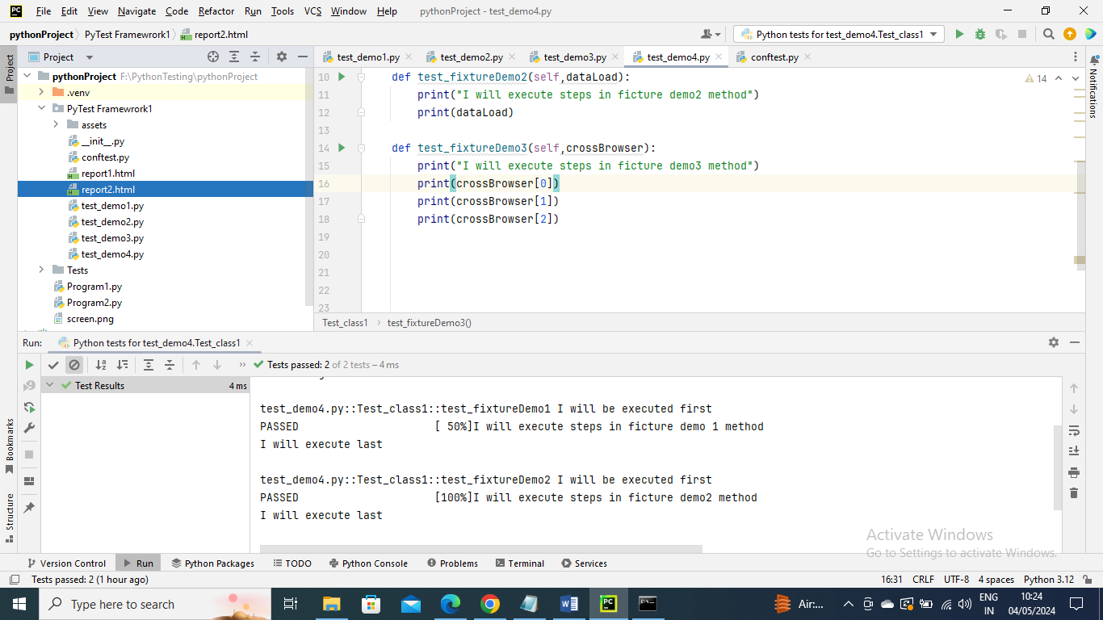

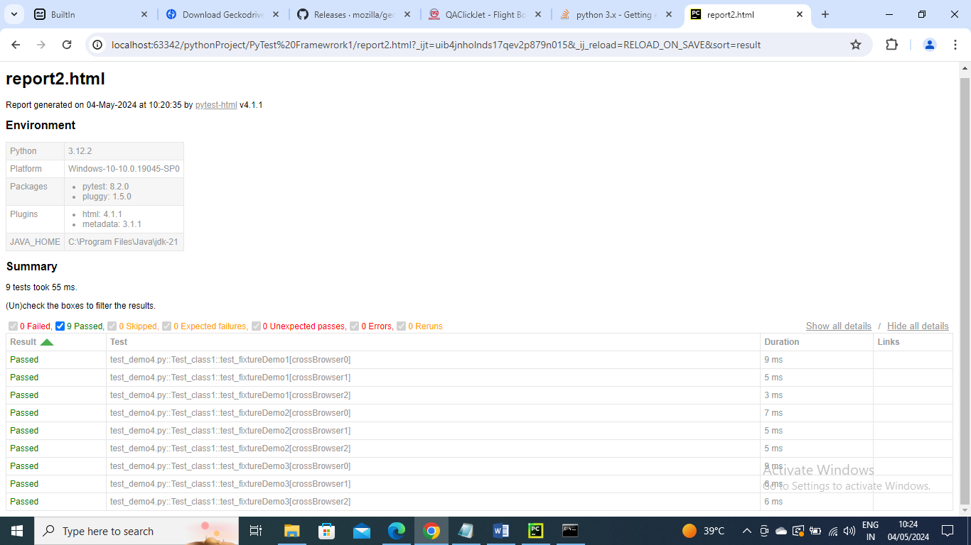

--------------------

Logging in Python

You can give some meaning info as logs for any issues or errors or any info

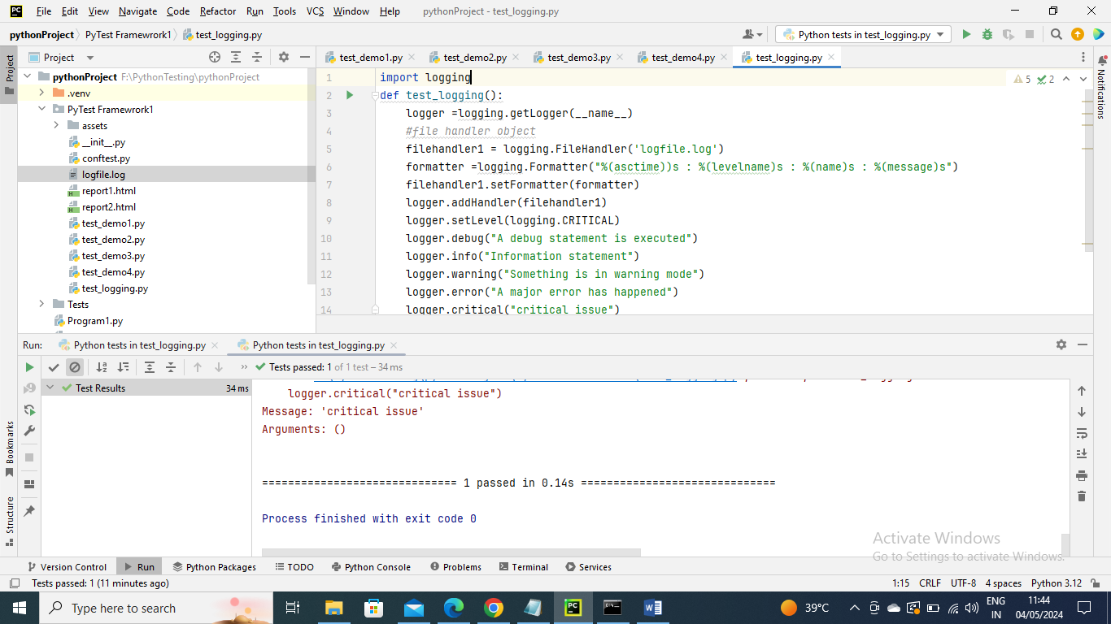

Now run the above a logfile.log gets created and it has the info of level

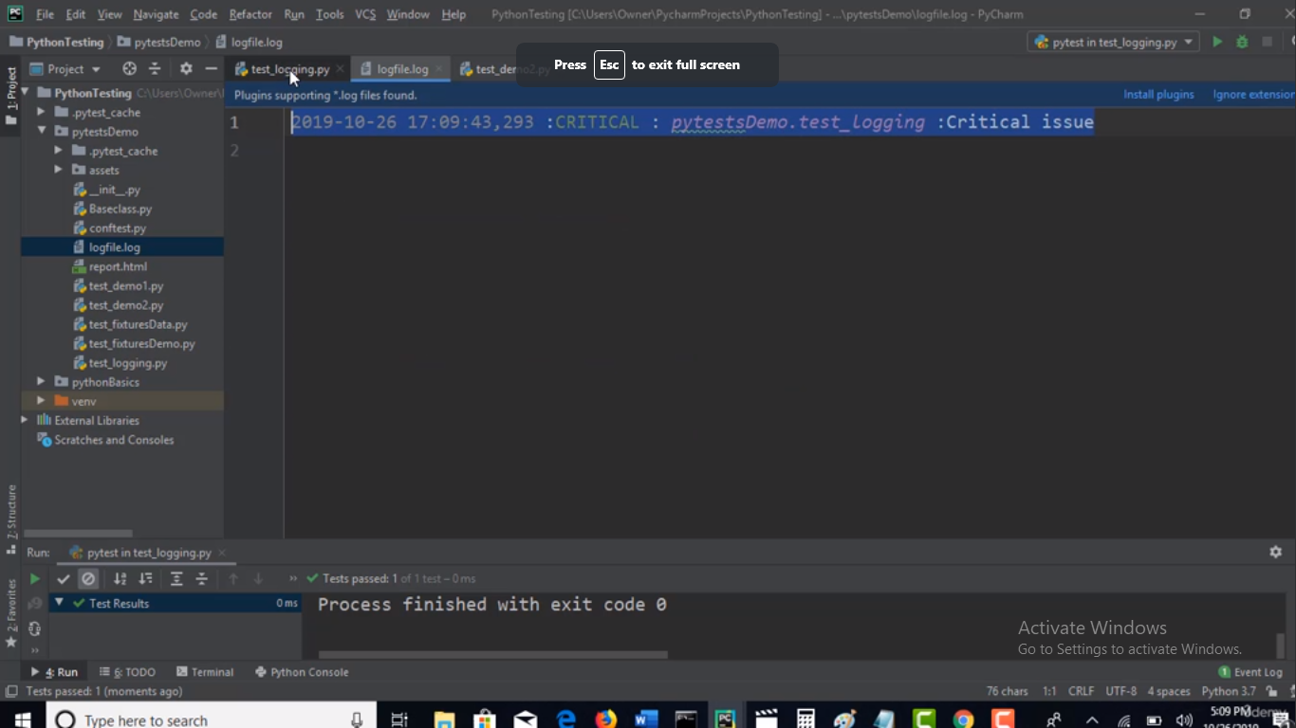

If set level is INFO we get below

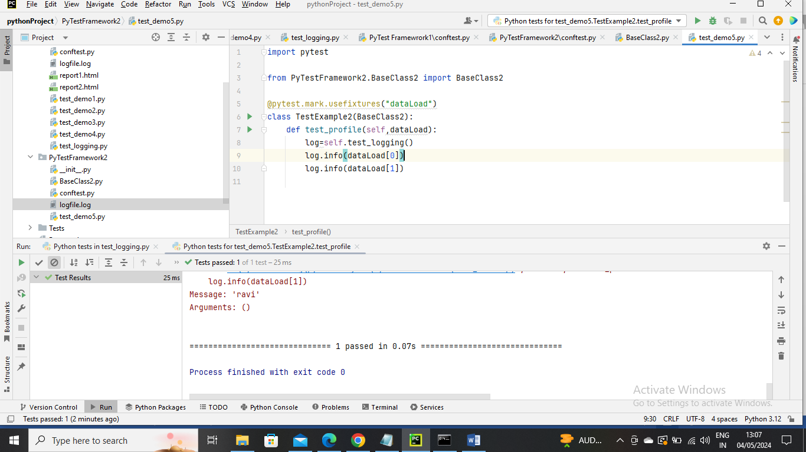

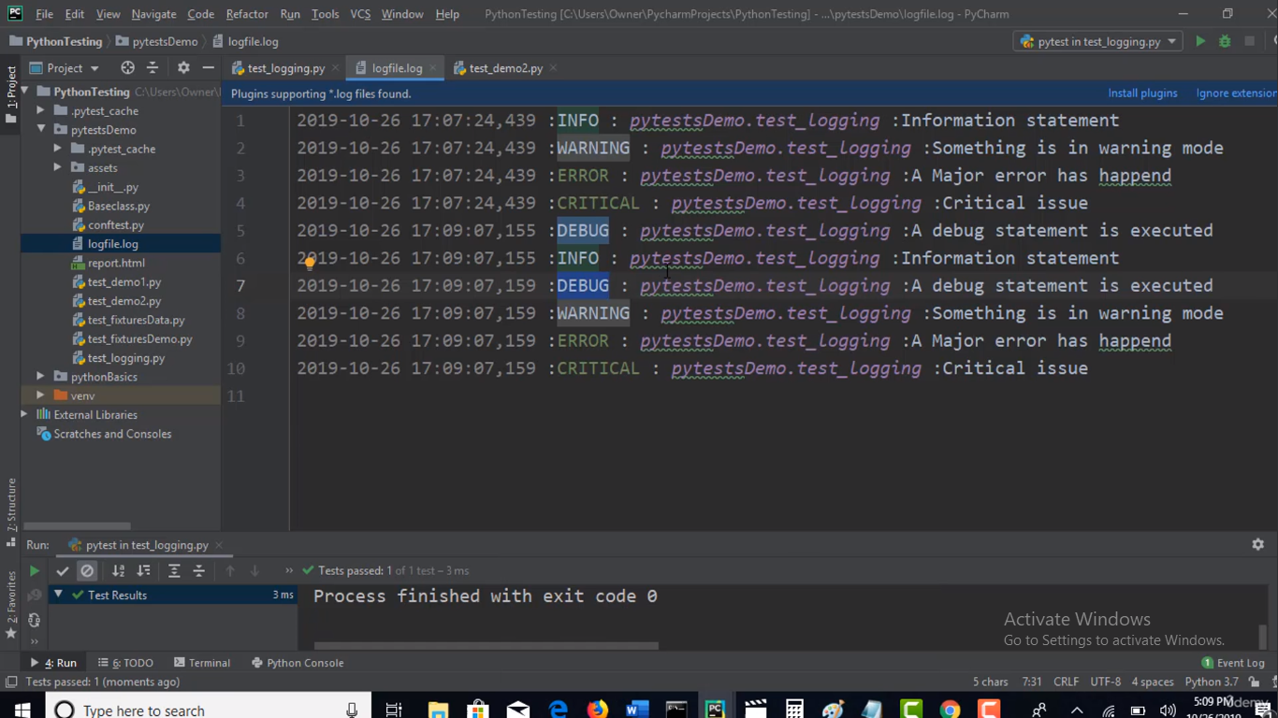

--------

Now let’s use the logging in our actual program requirements

Let’s say we want log the data info from Data Load

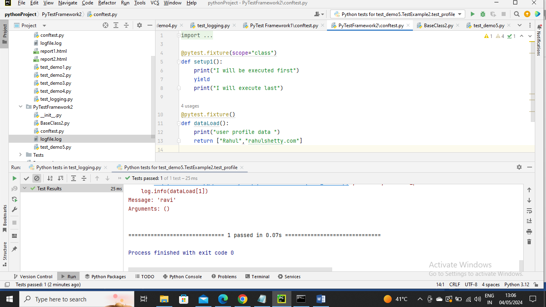

Now created the logger file as below where logfile.log gets created (if created gets replaced) every time for run

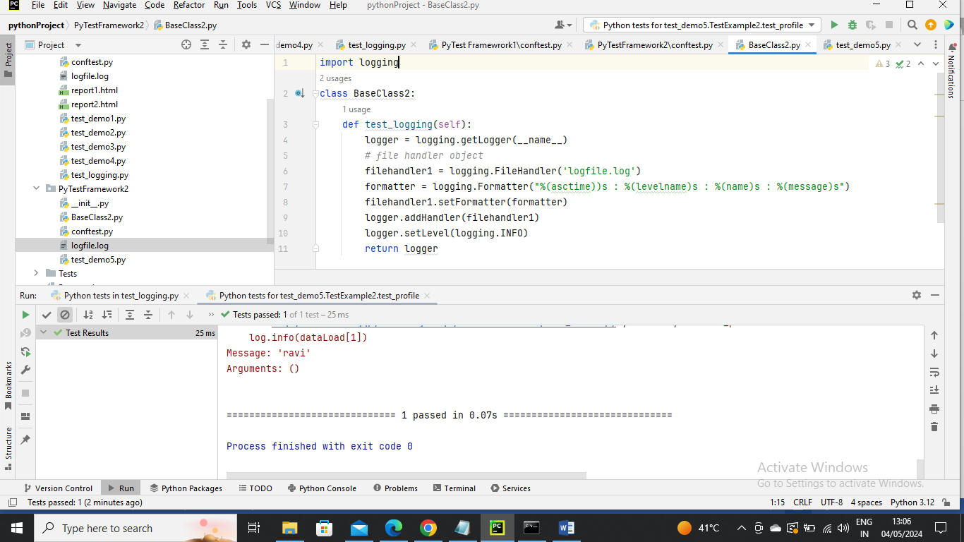

Now use the BaseClass2 as parent program and inherit its method and log the data in log file as below

